Linux Commands

1> Pwd: pwd stands for Print Working Directory. It prints the path of the working directory, starting from the root.

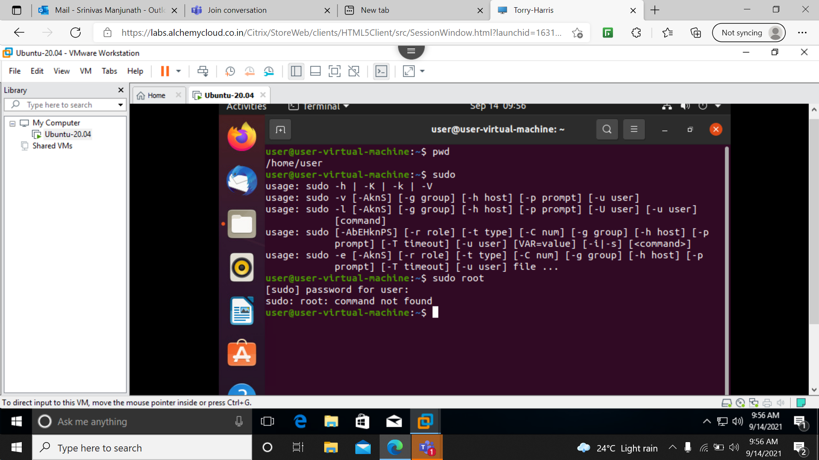

2> clear: clears your screen if this is possible. Clear ignores any command-line parameters that may be present.

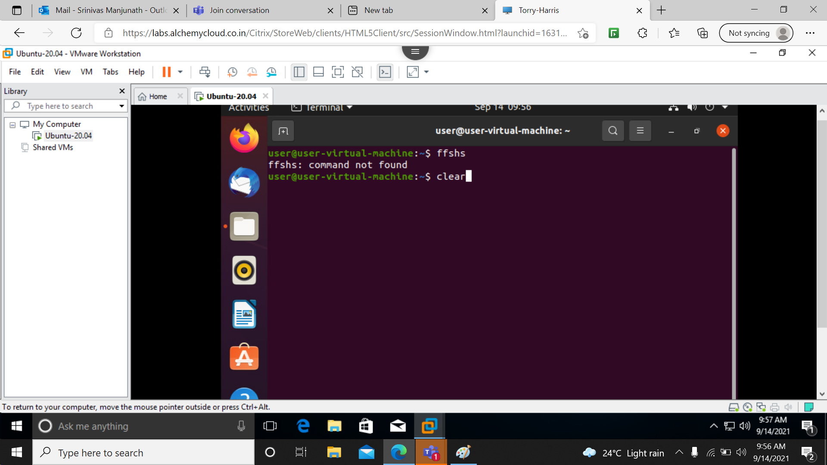

3> ls: The **ls** is the list command in Linux. It will show the full list or content of your directory. Just type *ls* and press the enter key.

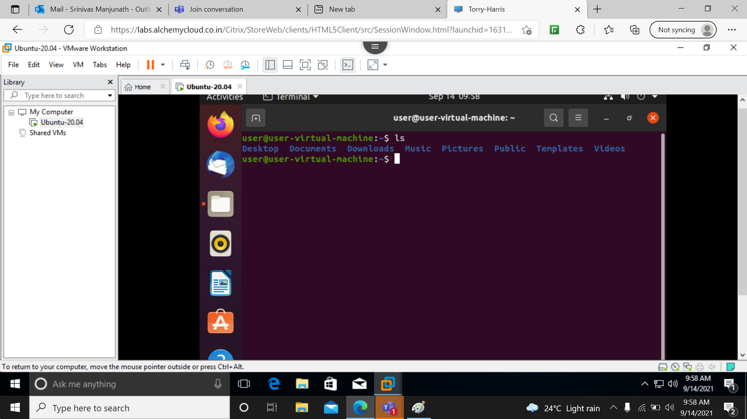

4> ls –l: It will show the list in a long list format.

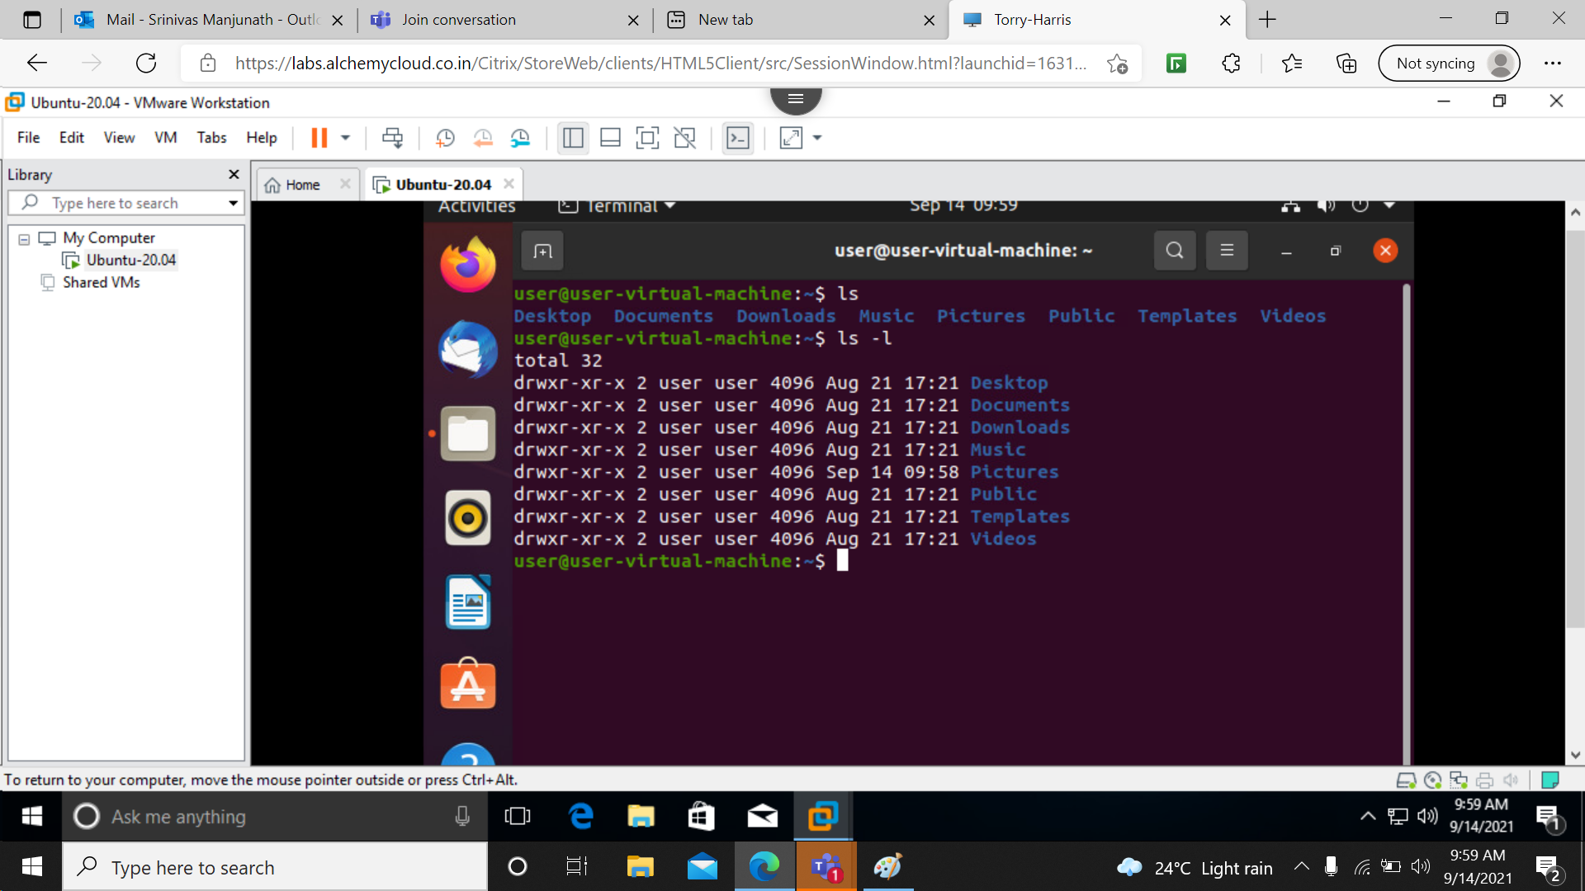

5> cd: cd stands for ‘change directory’. It enables you to change the working directory from the current directory to the desired directory that you wish to navigate to.

6> cd ..: cd.. Is used to come one step back.

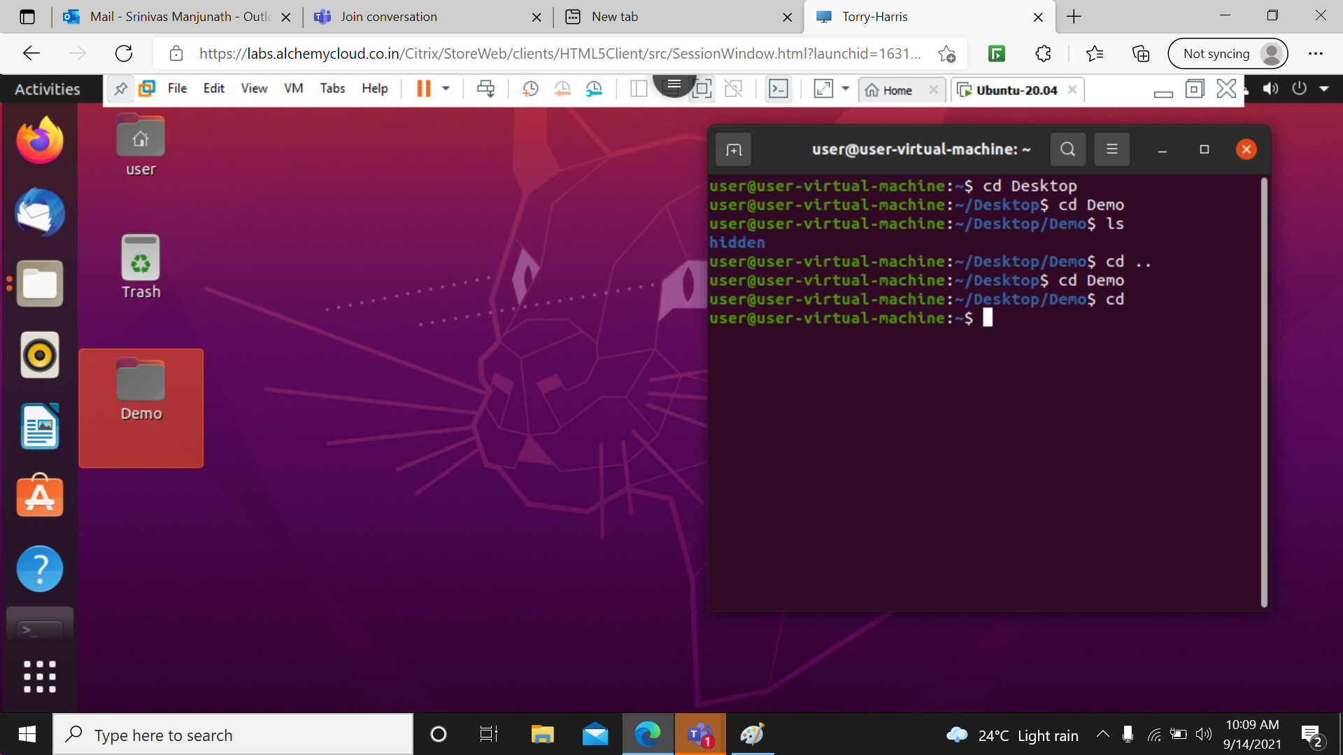

7> cd /: it is used to shift to root directory, Root directory is the most important directory in the Linux file system. It is the parent directory to all other directories present in the file system. It is denoted by /.

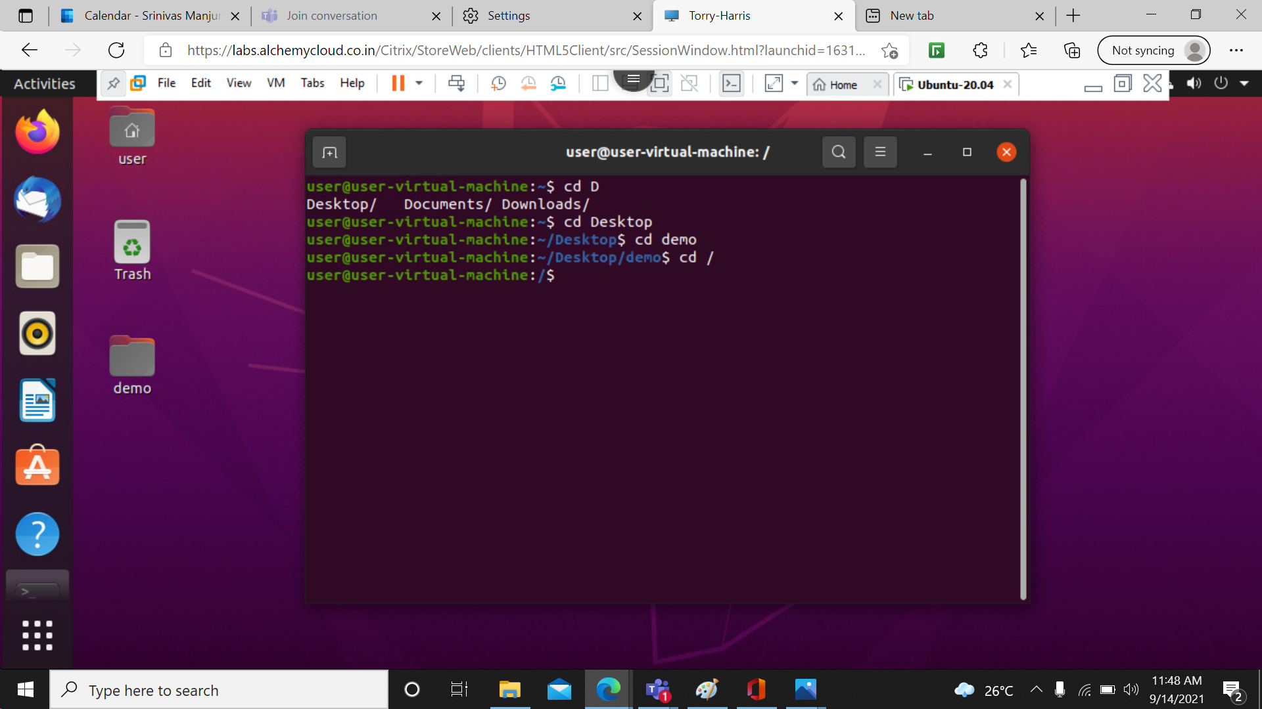

8> ls-f : it is used to show all the hidden folders without format.

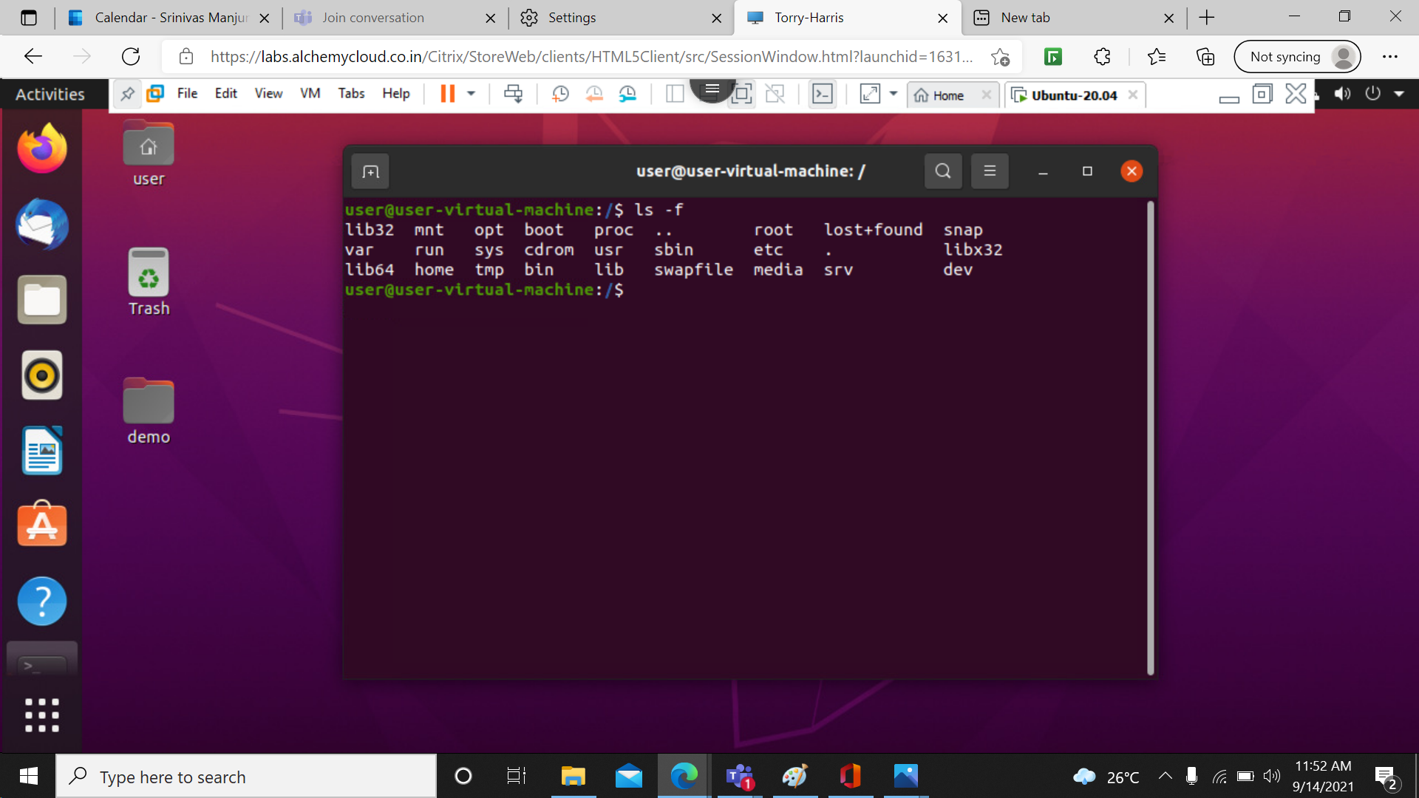

9> ls-a: In Linux, hidden files start with. (dot) symbol and they are not visible in the regular directory. The (ls -a) command will enlist the whole list of the current directory including the hidden files.

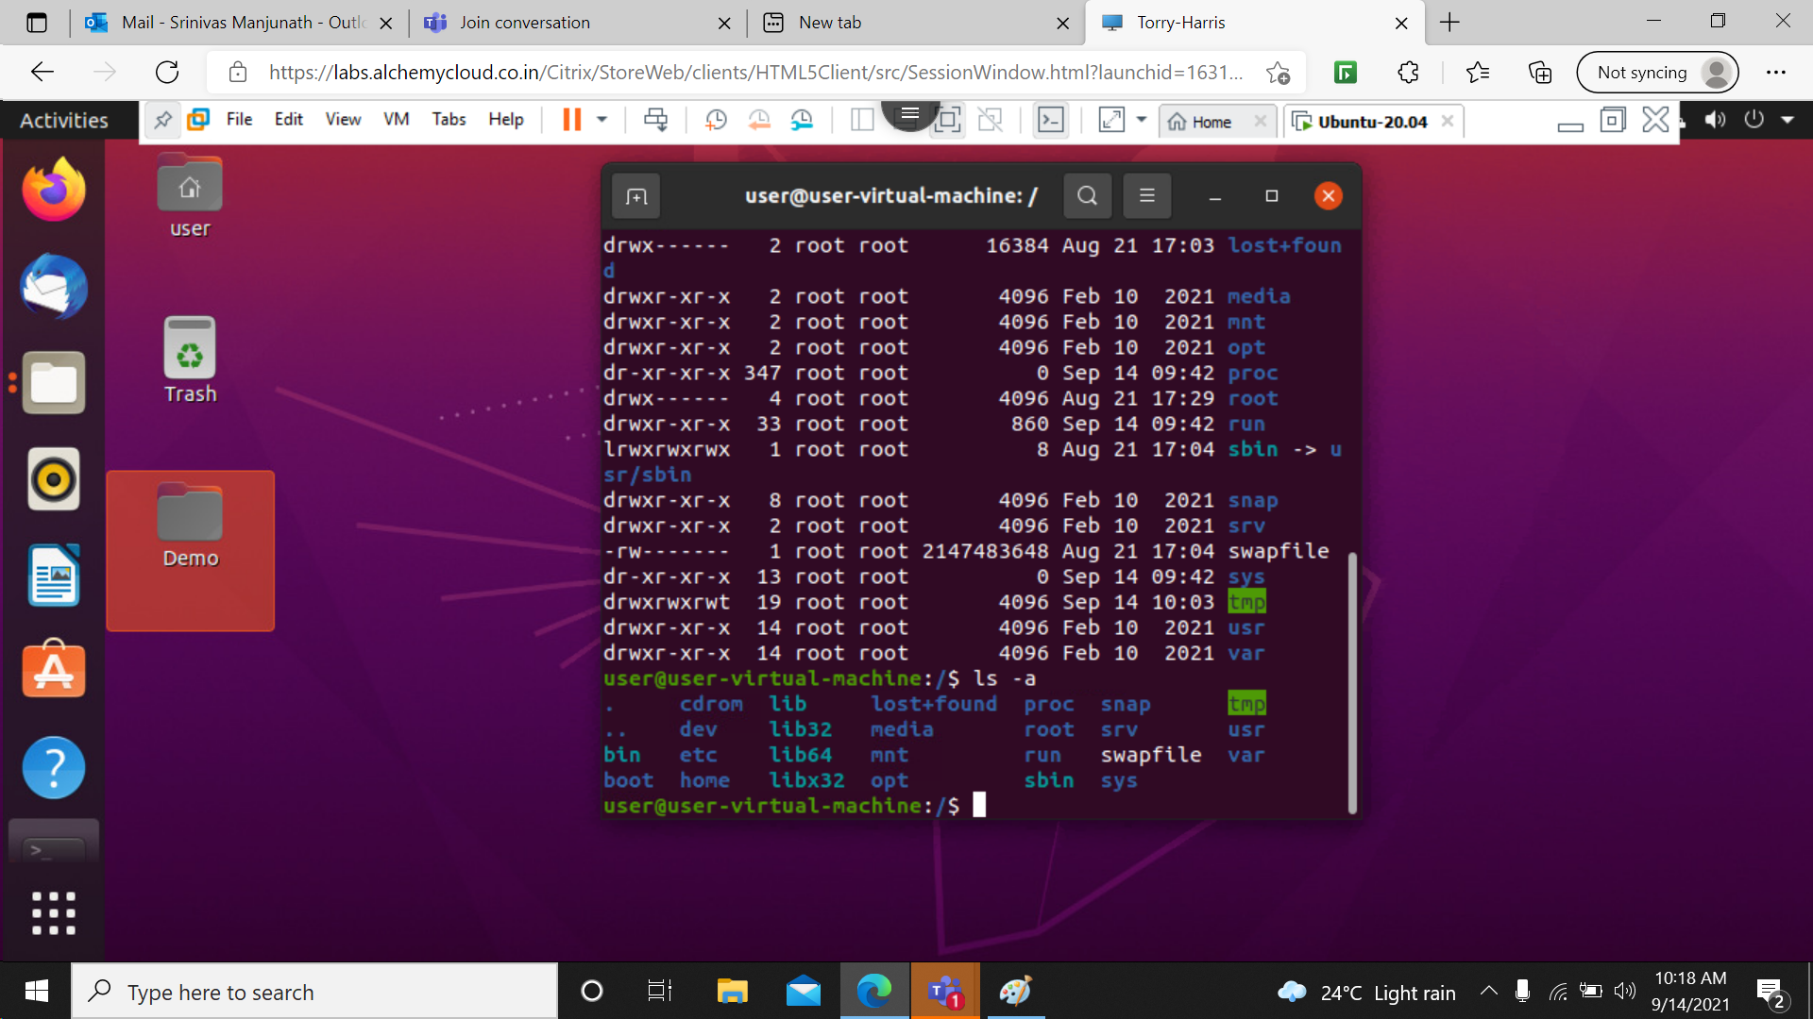

10> exit: exit command in Linux is used to exit the shell where it is currently running.

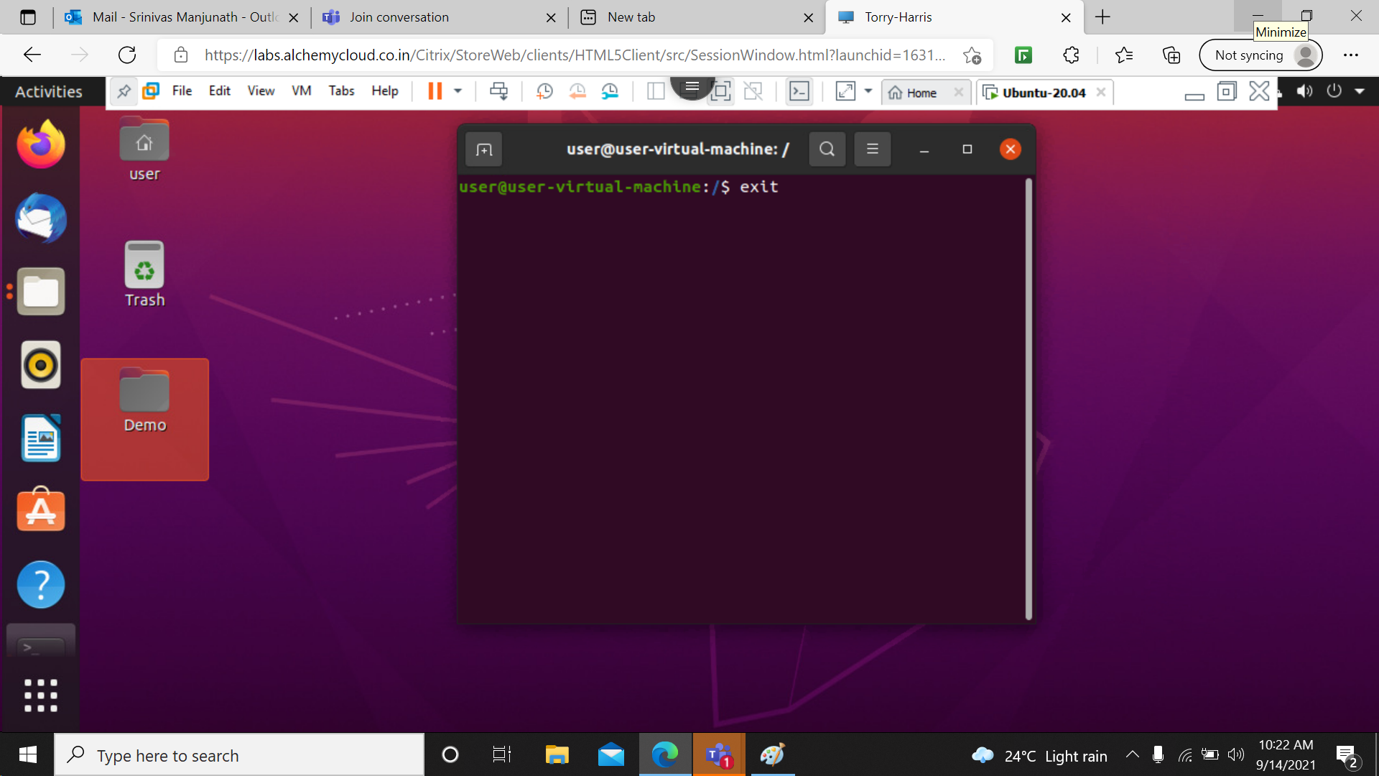

11> cat – used for concatenation and reading text from file. It reads data from the file and gives their content as output. It helps us to create, view, concatenate files. So let us see some frequently used cat commands.

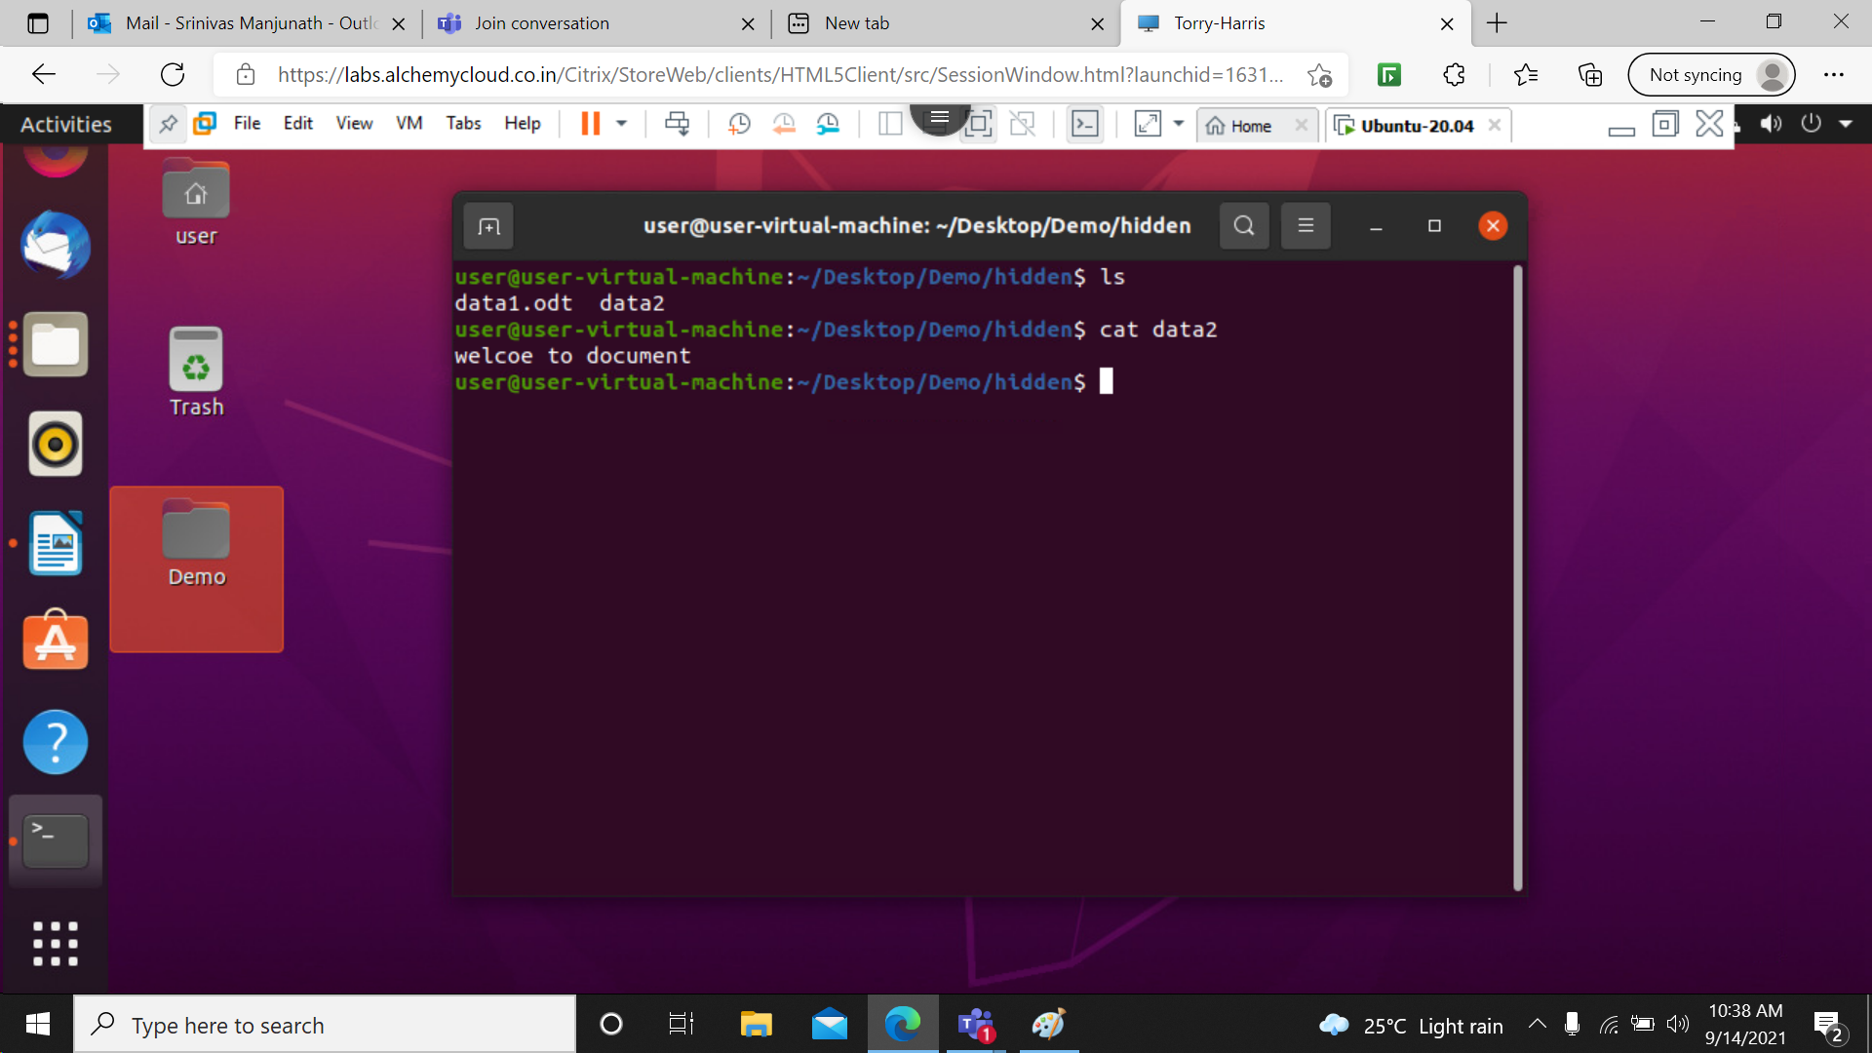

12> man - man it is the interface used to view the system's reference manuals.

13> man –ls: lists the manual for list.

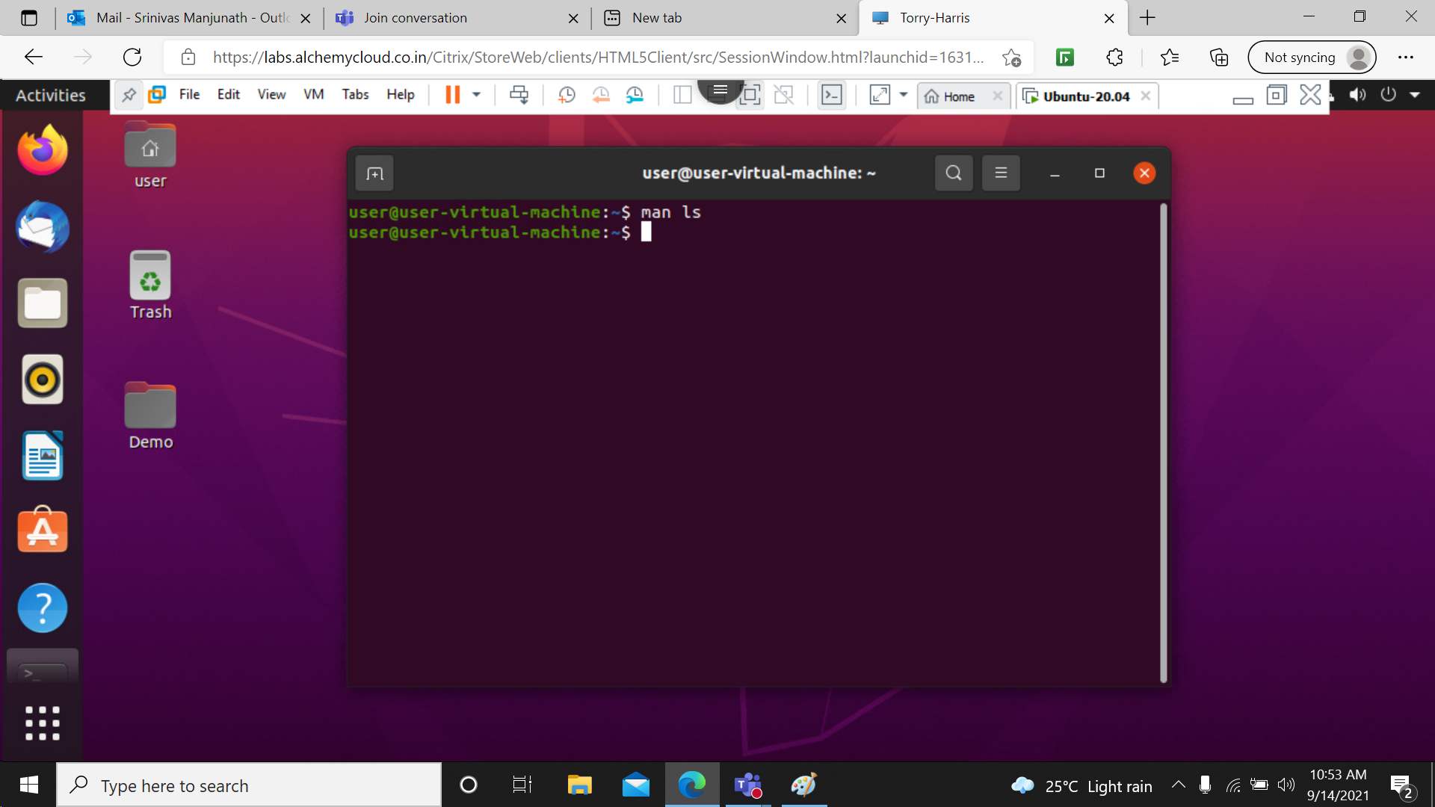

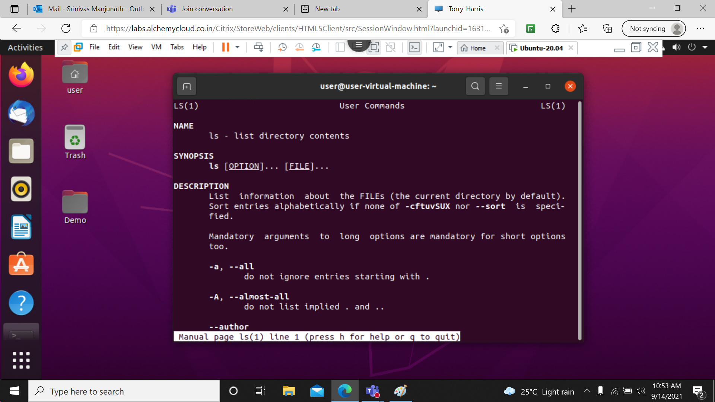

14> man pwd: Print the full filename of the current working directory.

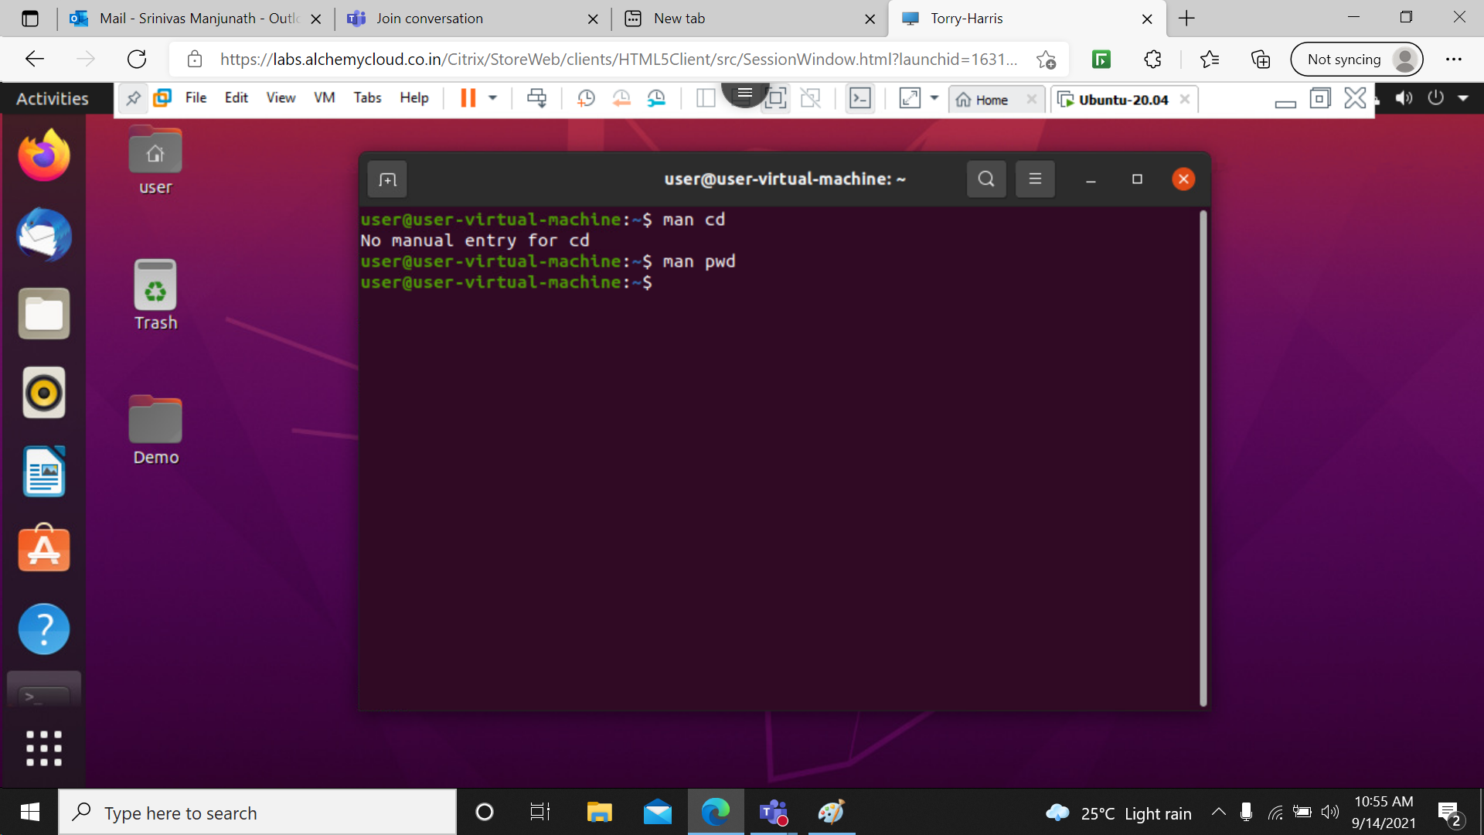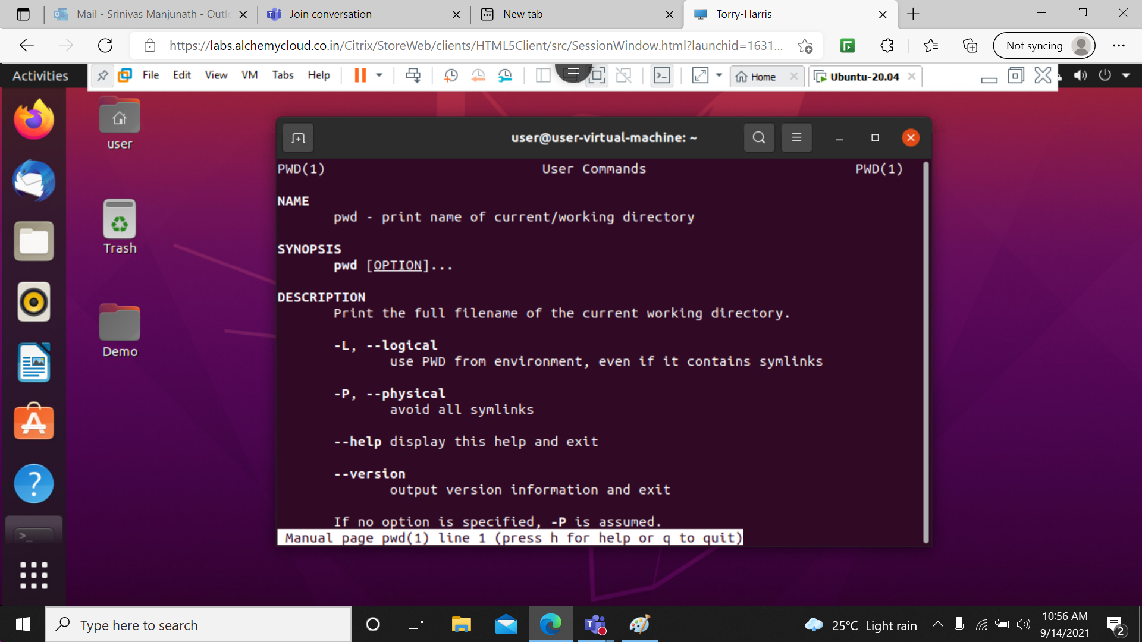

15> echo: is used to print the information/message to your terminal.

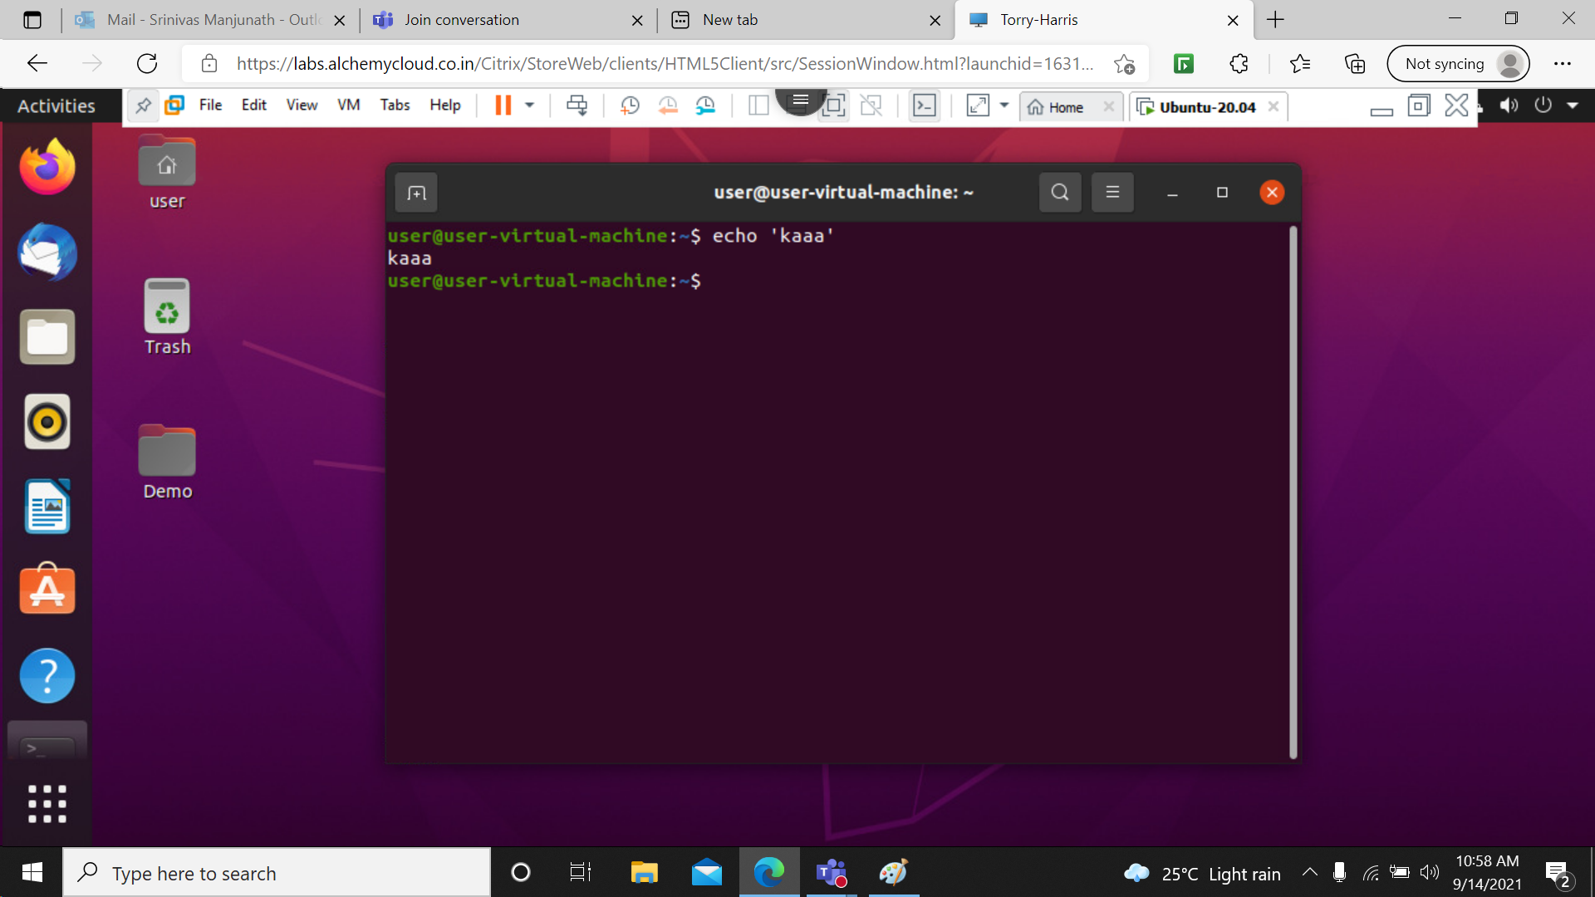

16> path: s used to find the path of the Linux binary /executable files, source files and man page files.

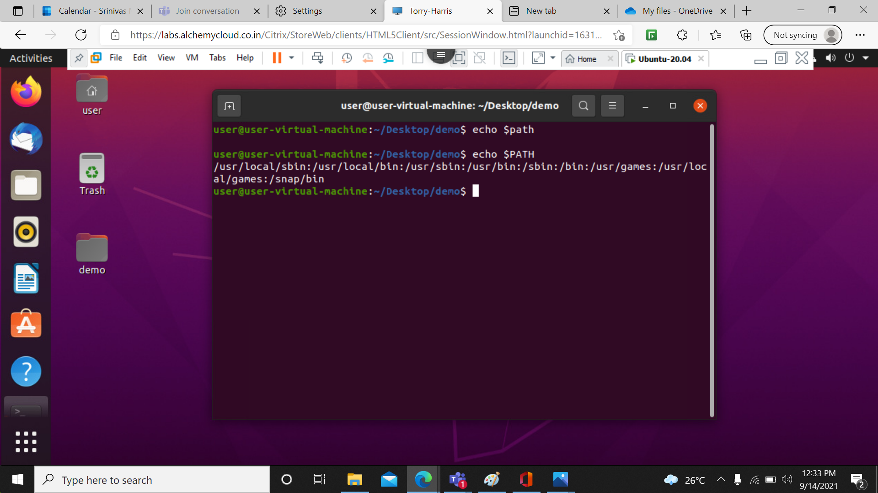

17> mv: mv command is used to move existing file or directory from one location to another. It is also used to rename a file or directory.

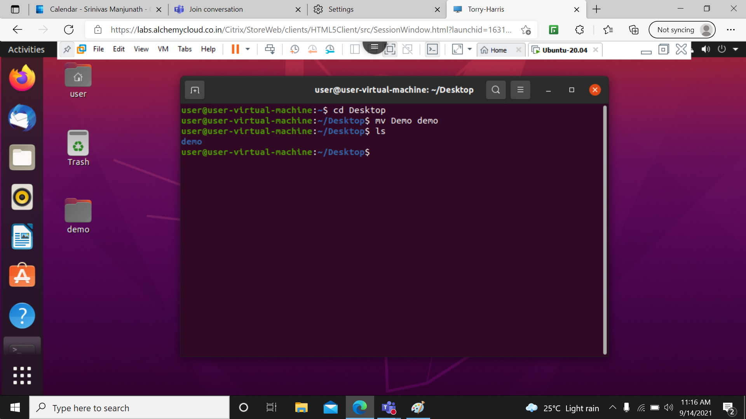

18> mkdir: You can create directories one by one with mkdir, but this can be time-consuming. To avoid that, you can run a single mkdir command to create multiple directories at once.

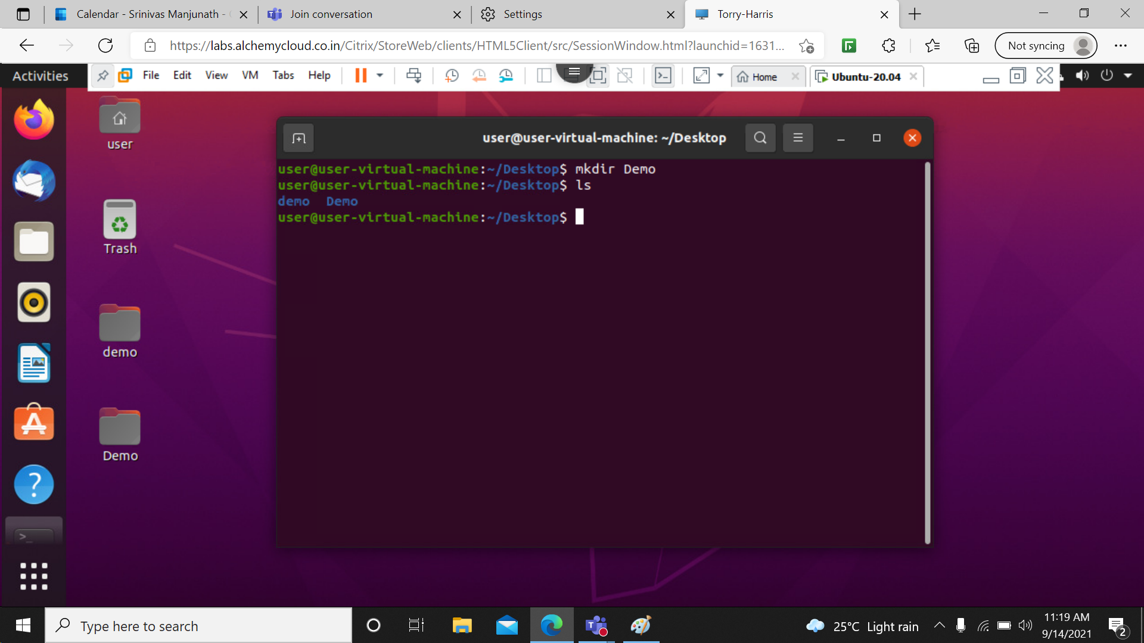

19> rmdir: rmdir command is used remove empty directories from the filesystem in Linux. The rmdir command removes each and every directory specified in the command line only if these directories are empty.

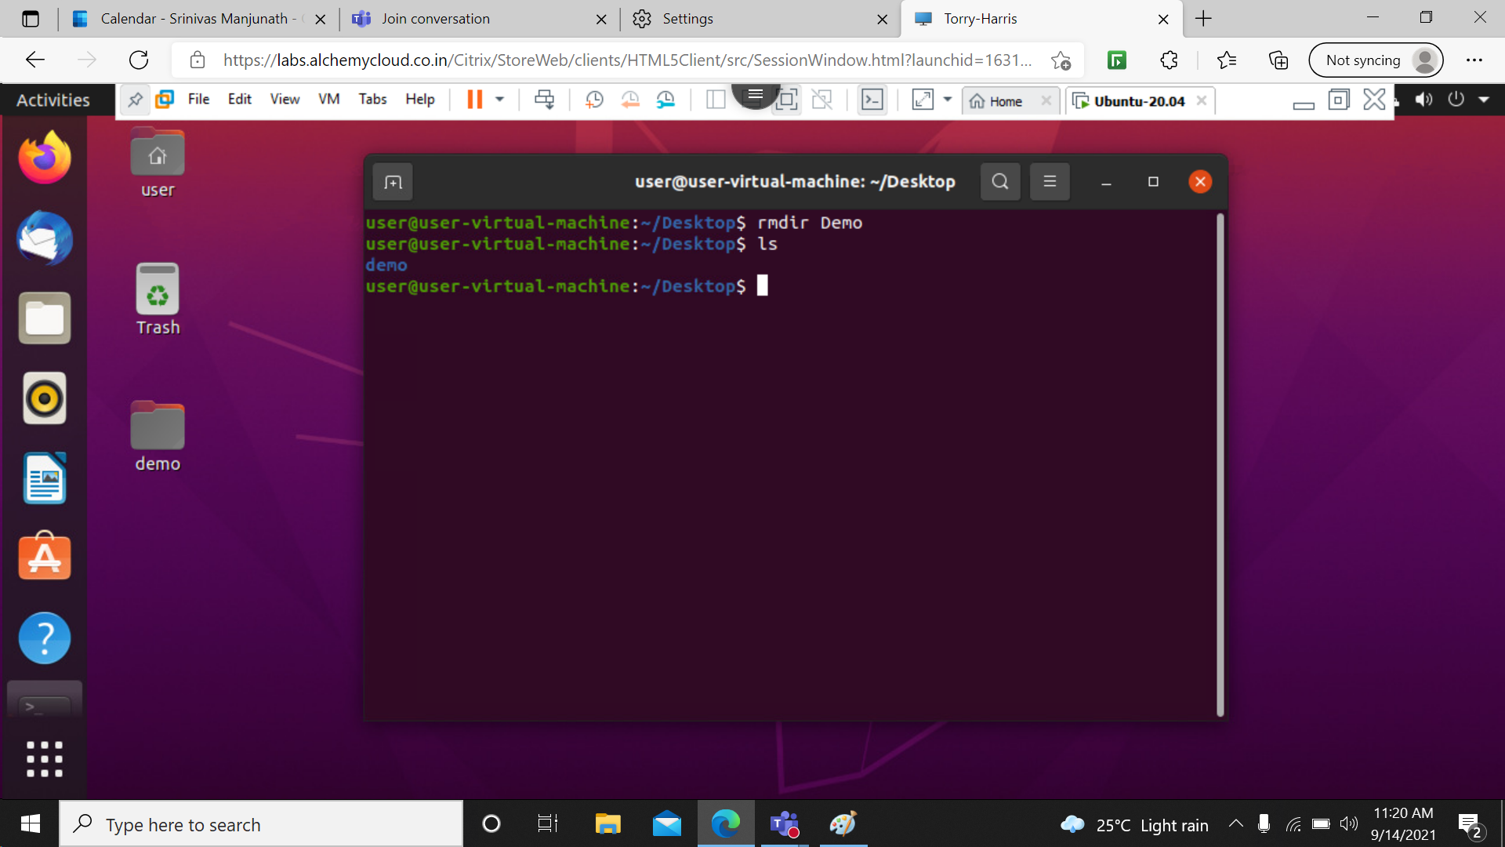

20> who: The who command is used to get information about currently logged in user on to system.

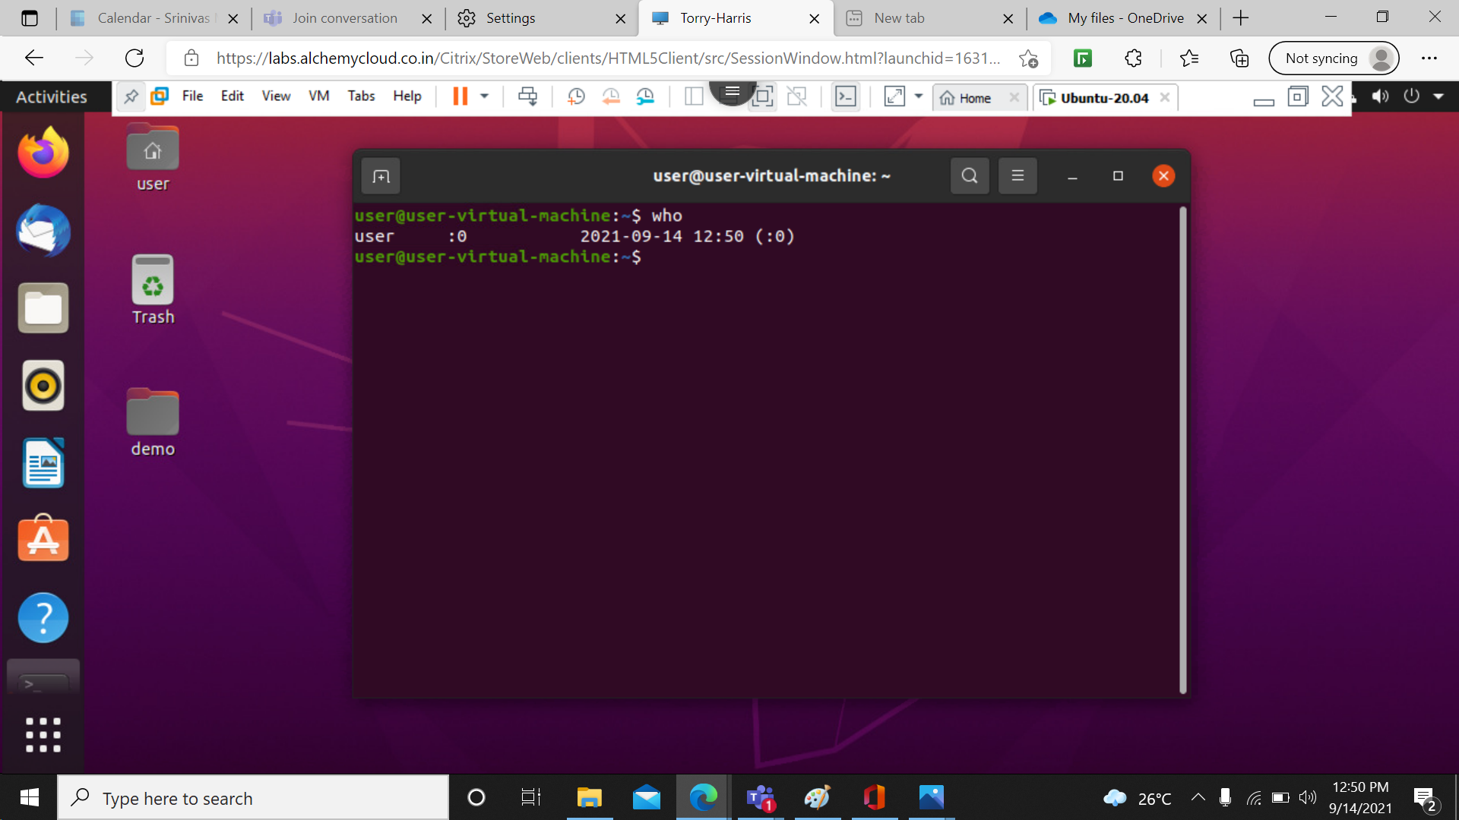

21> date: the date command is used for displaying the time and date of the system. Also, it is used for setting the time and date of the system.

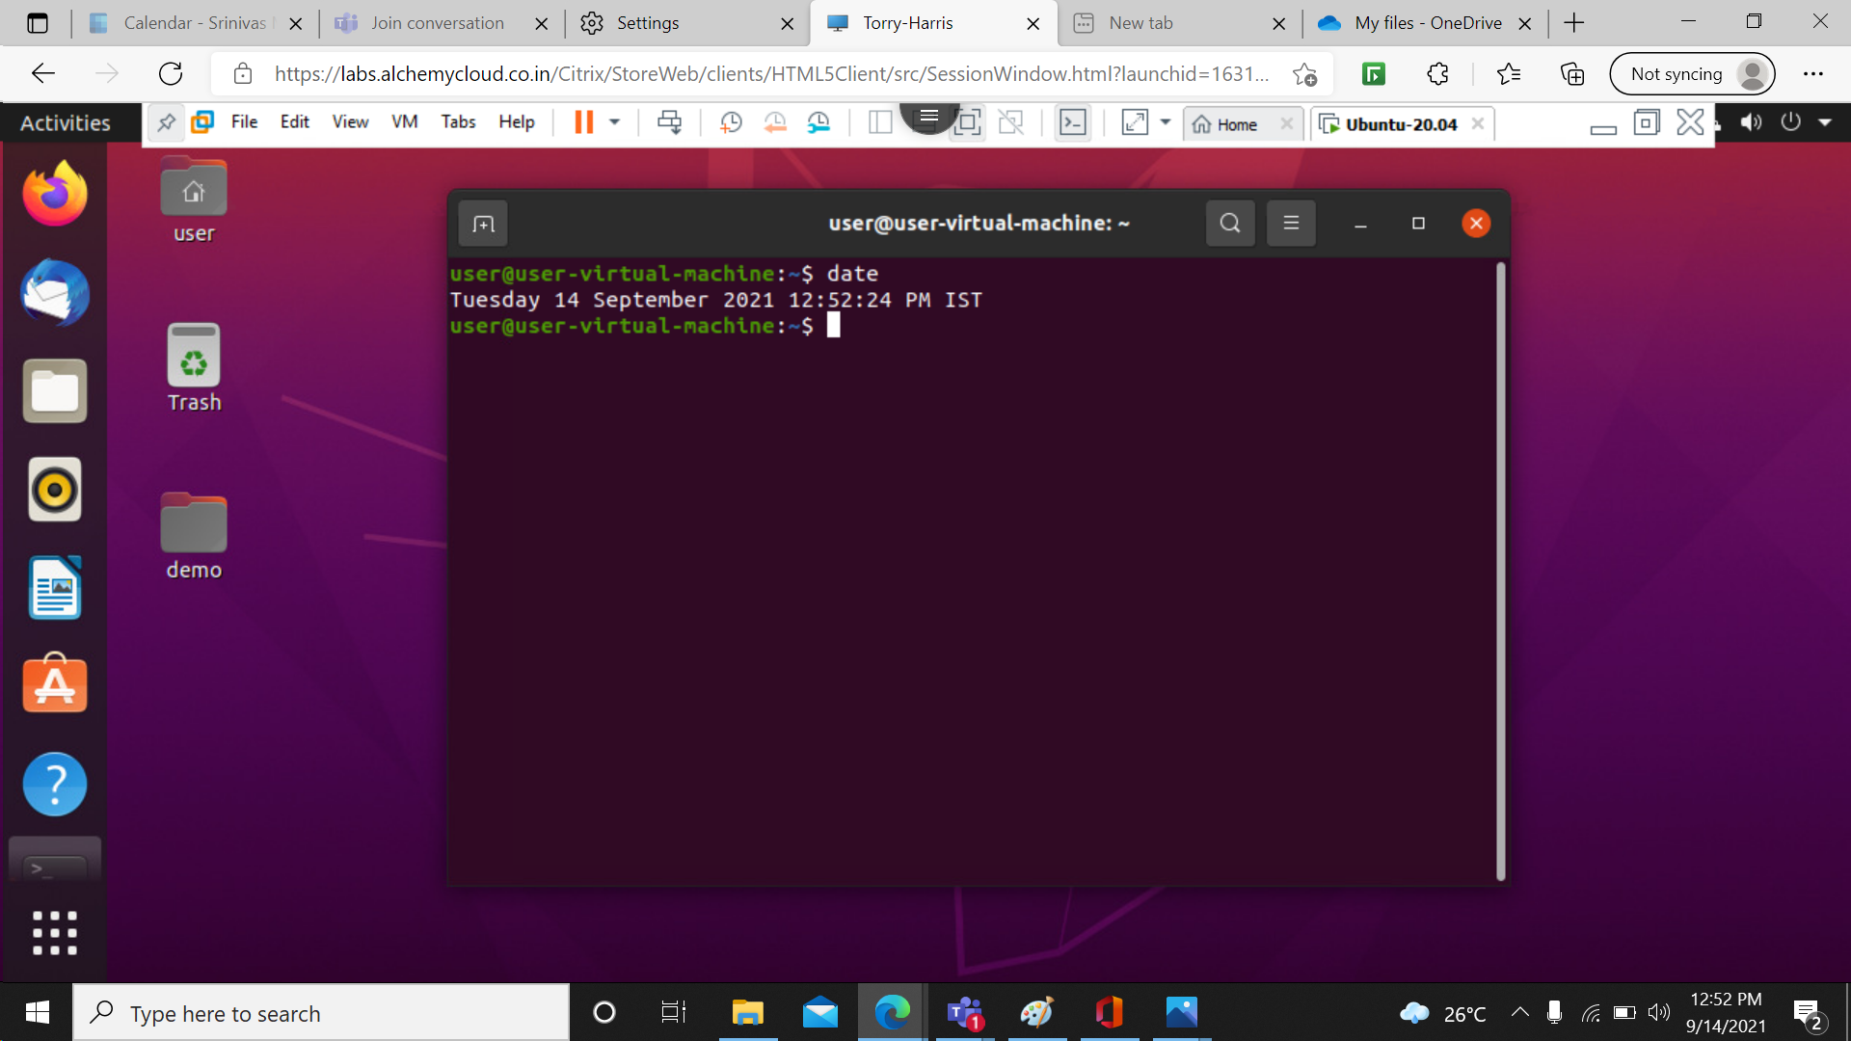

22> cal: To display a calendar.

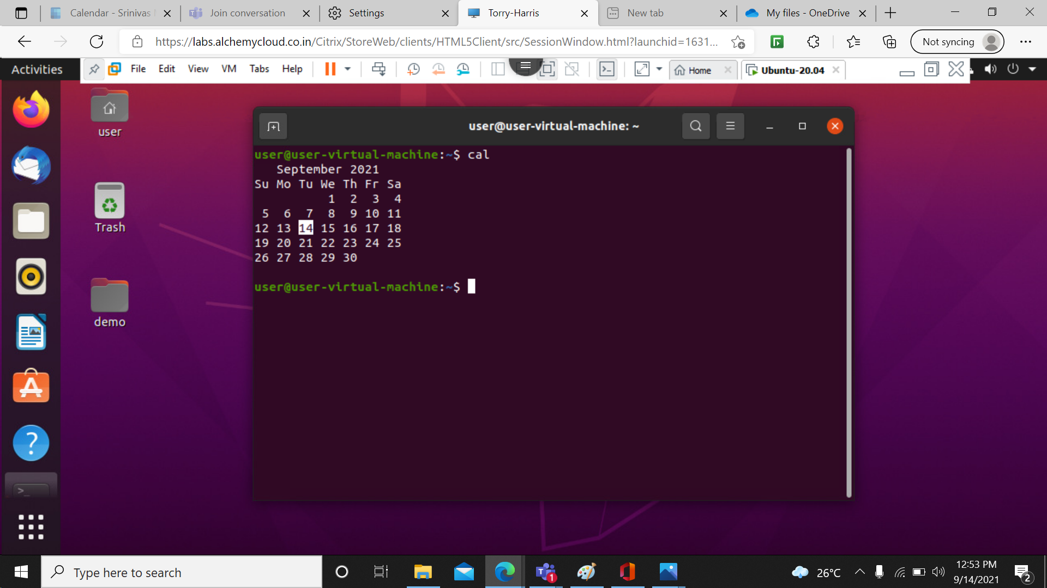

23> touch: touch command is a way to create empty files (there are some other mehtods also). You can update the modification and access time of each file with the help of touch command.

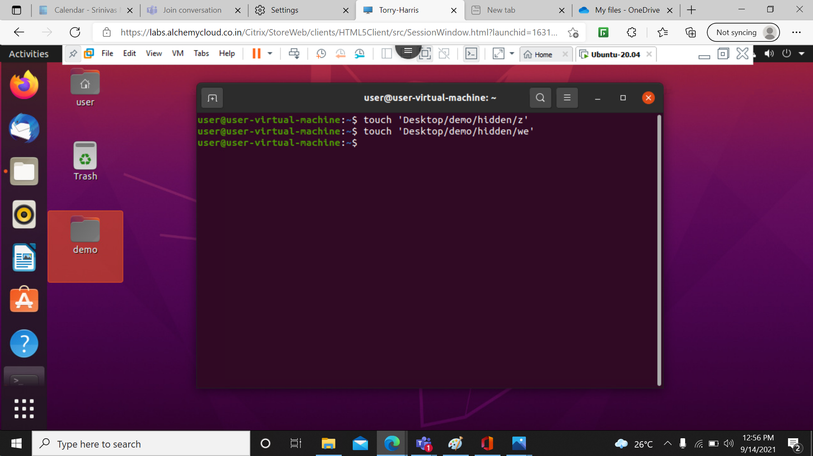

24> rm: rm is a command-line utility for removing files and directories.

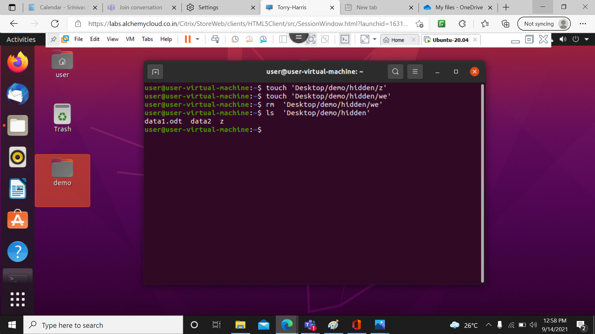

25> cp: The cp command has a simple purpose to copy files and folders from one place to another.

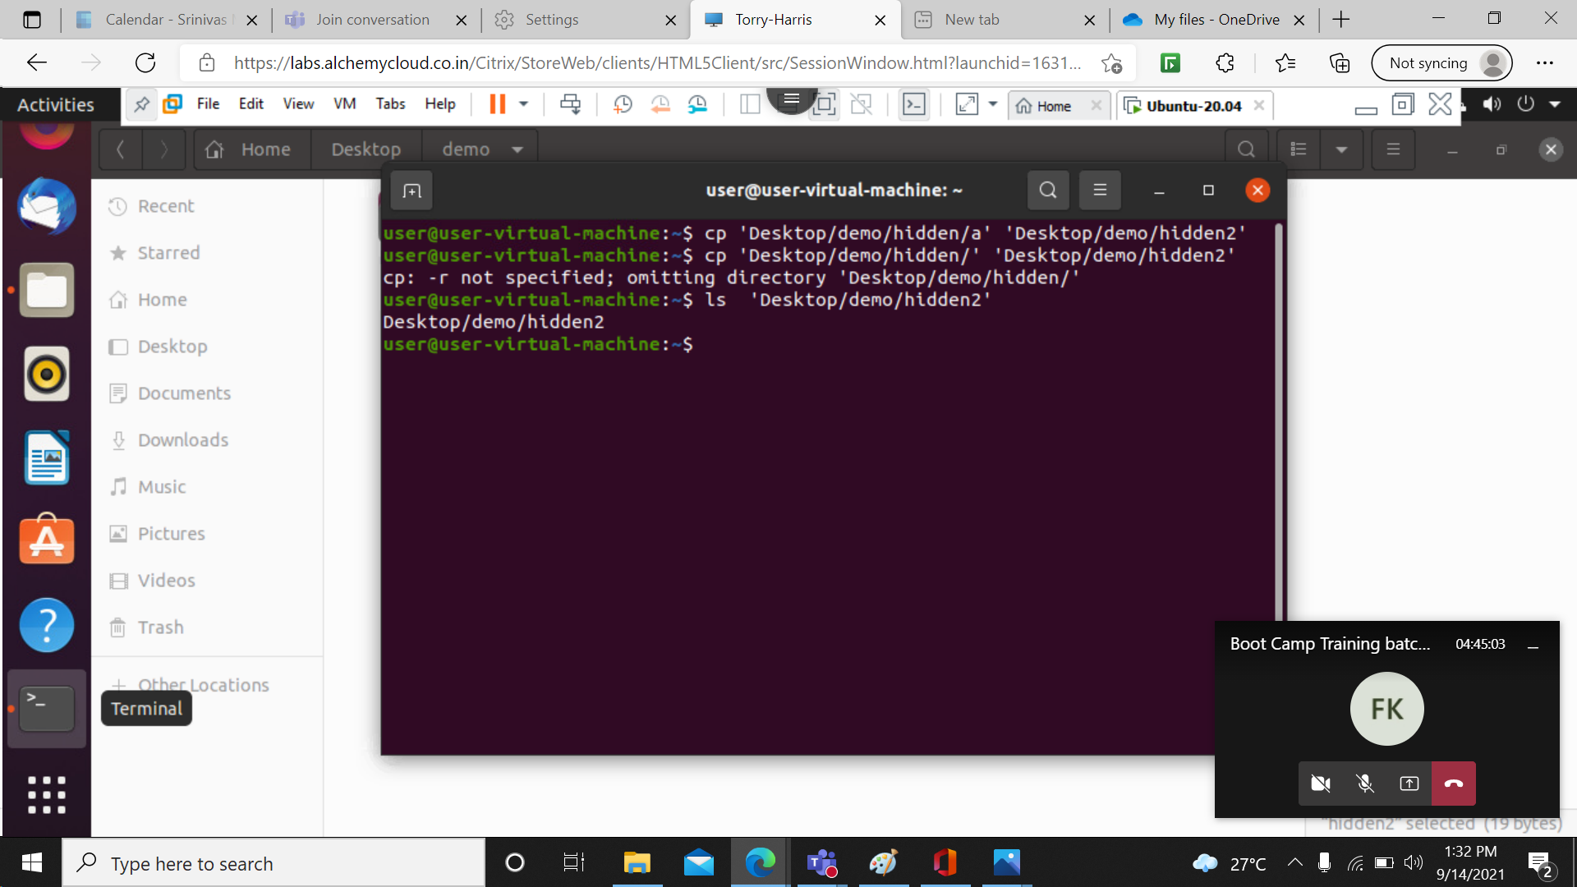

26> cp a z: it copies the data from source document to destination document.

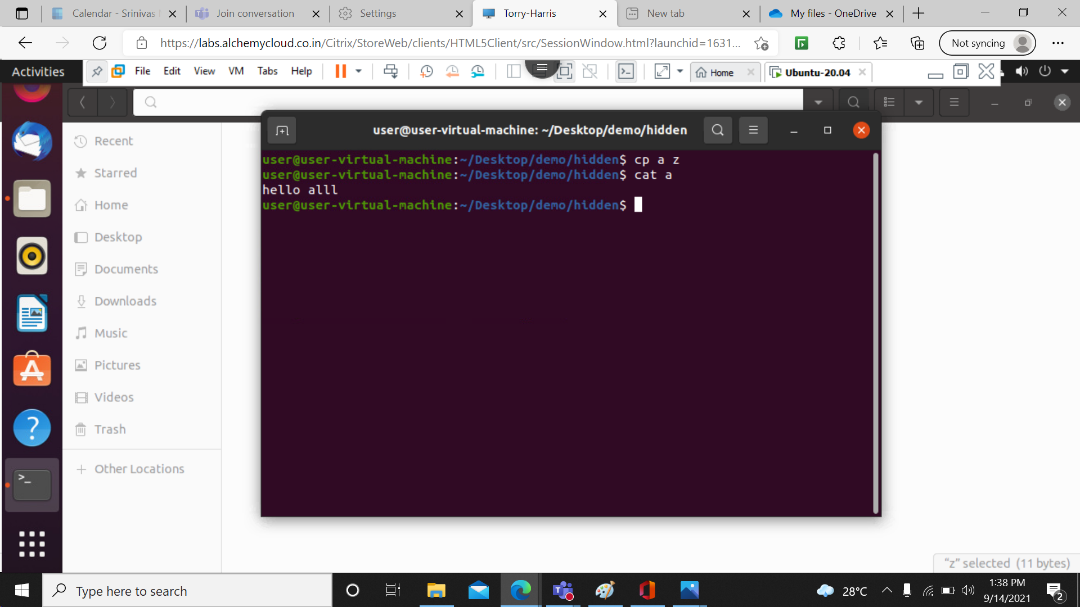

27> cat z: Display the data present in the document in order format.

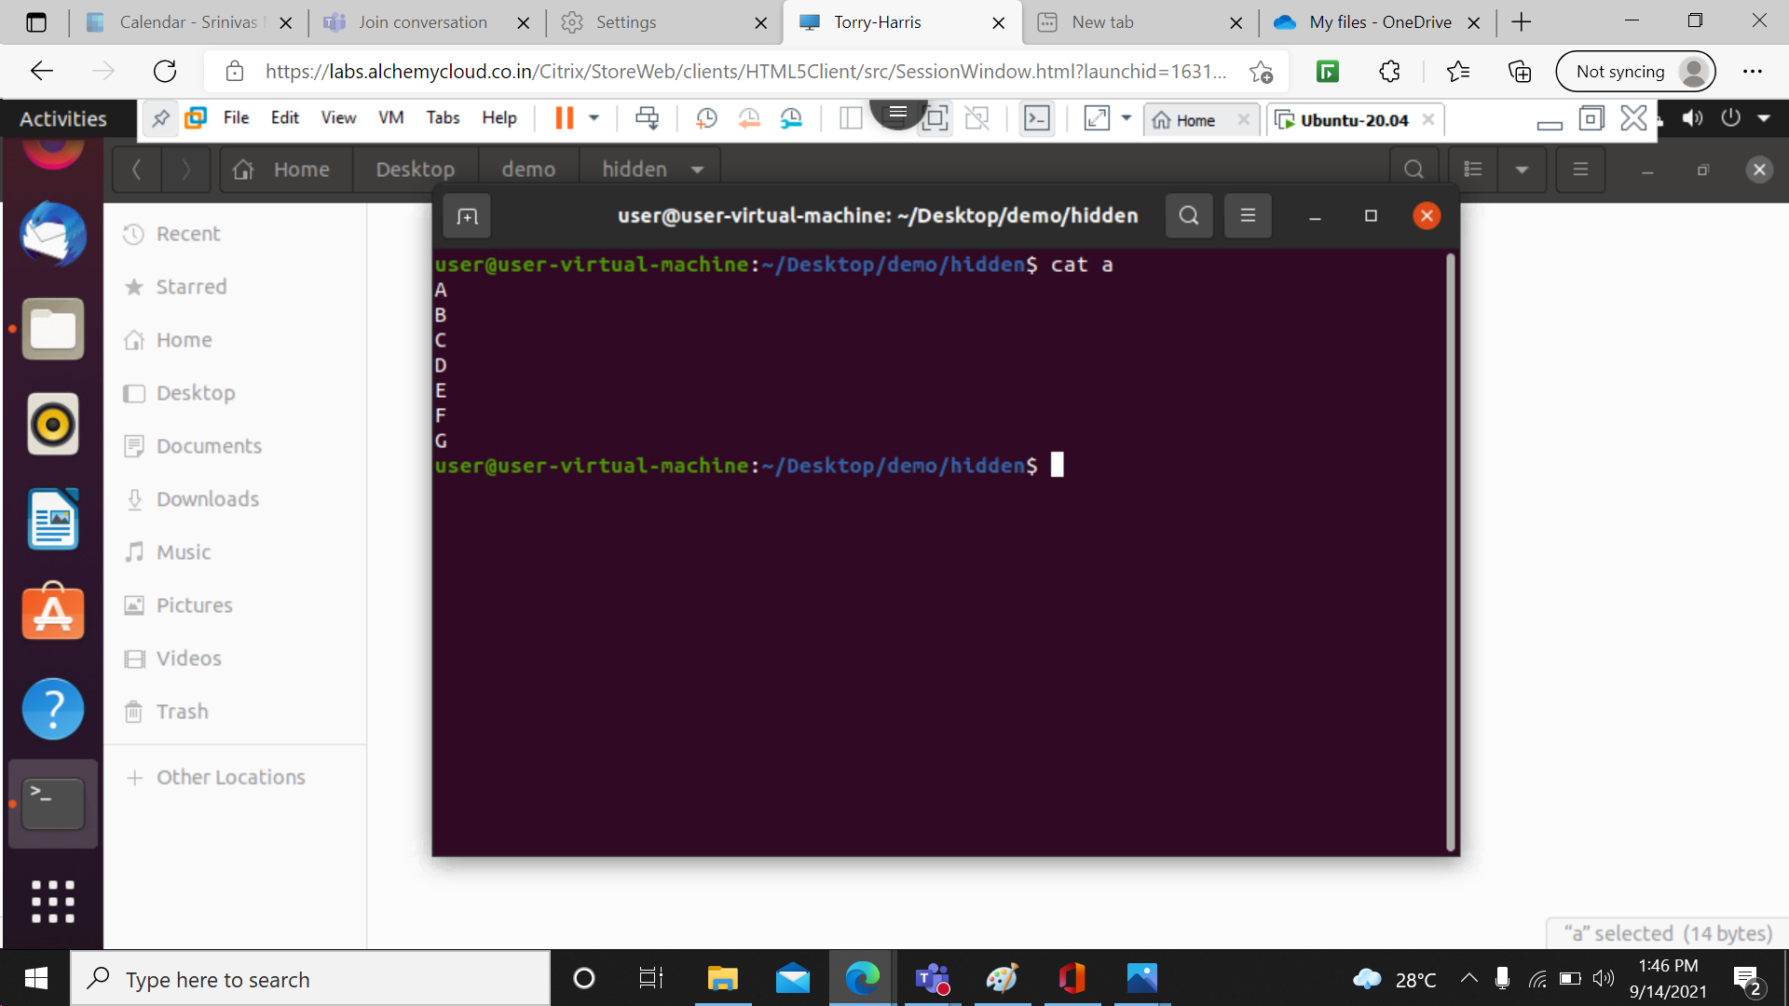

28> tac z: Display the data present in the document in reverse order format.

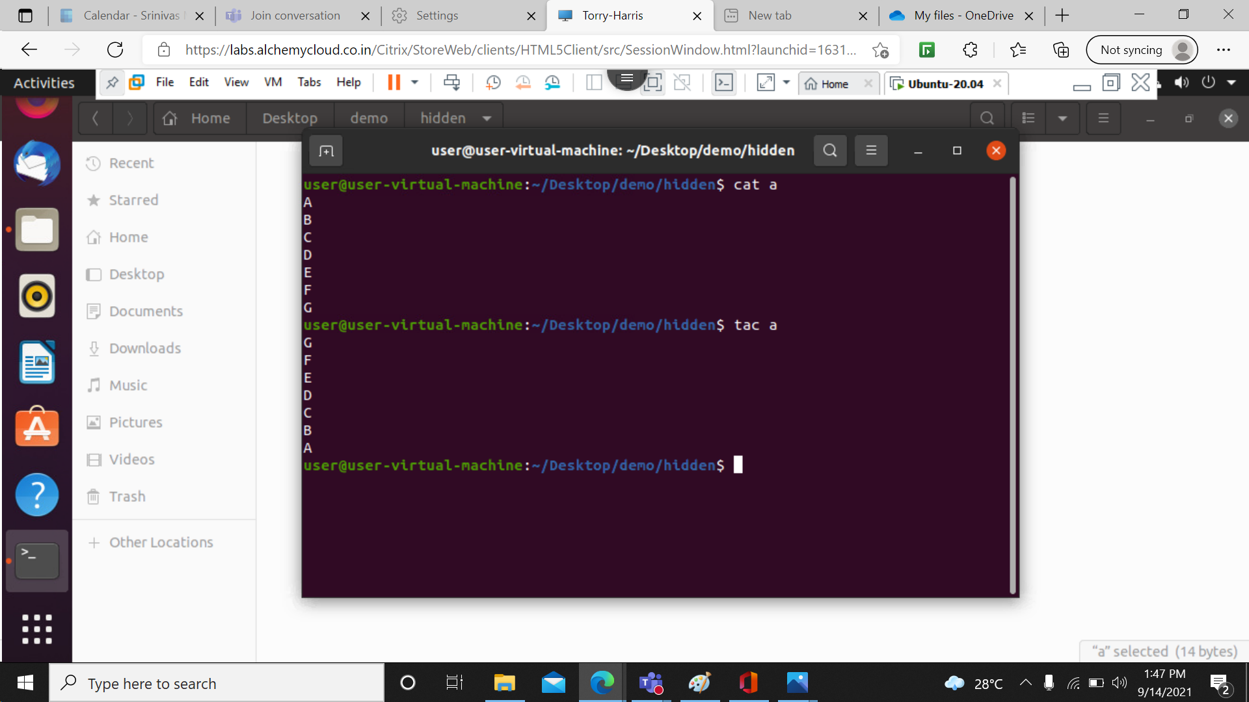

29> cat a z b: It is used to combine the data from all the documents.

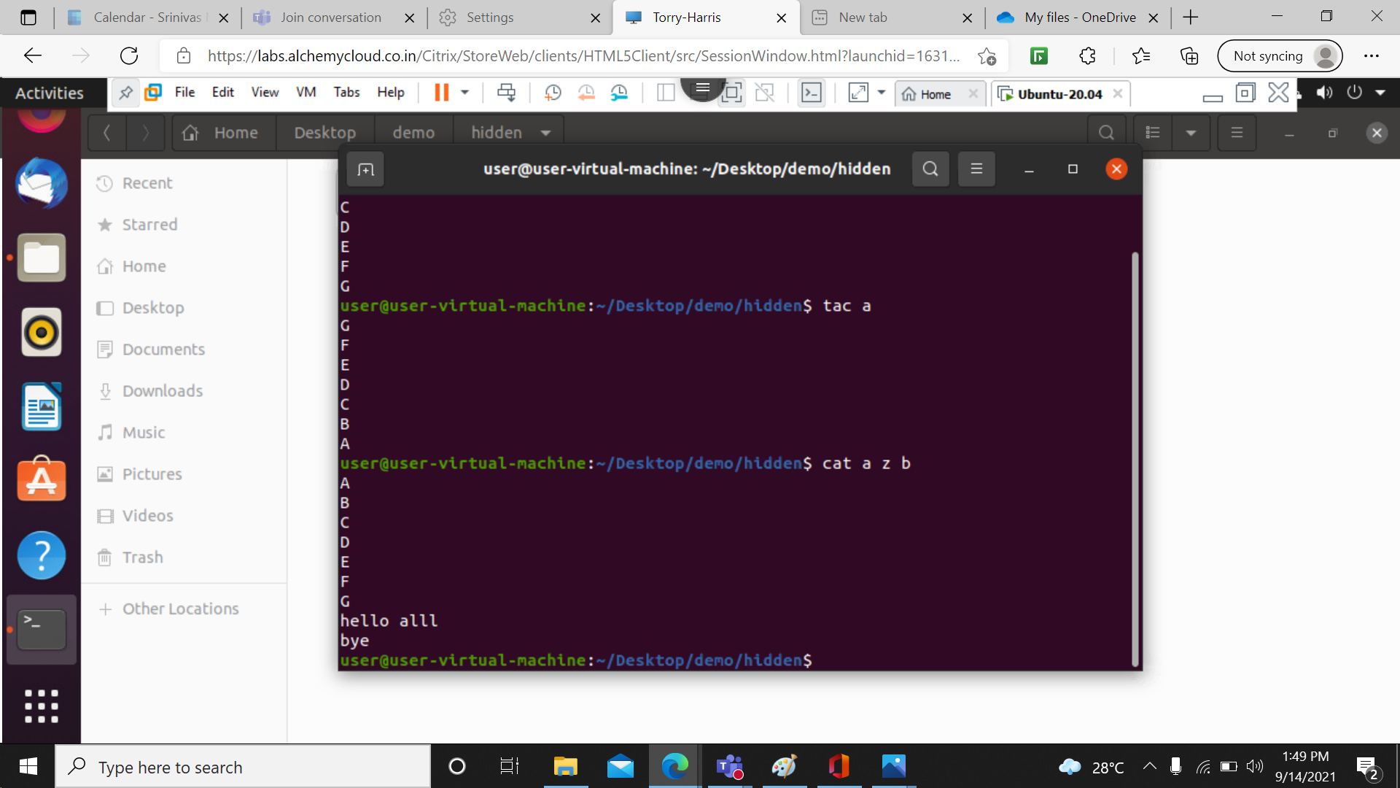

30> cat b>z: copies the data from source document (b) to destination document (z).

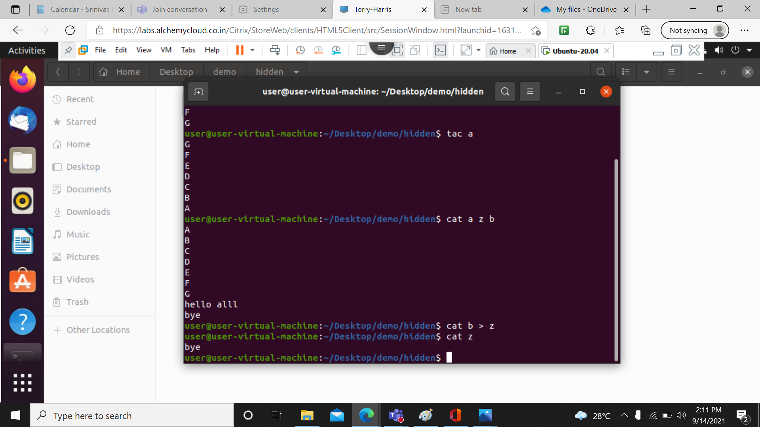

31> cat –b a: We use “-” symbol to display the line number, and combined data of two documents.

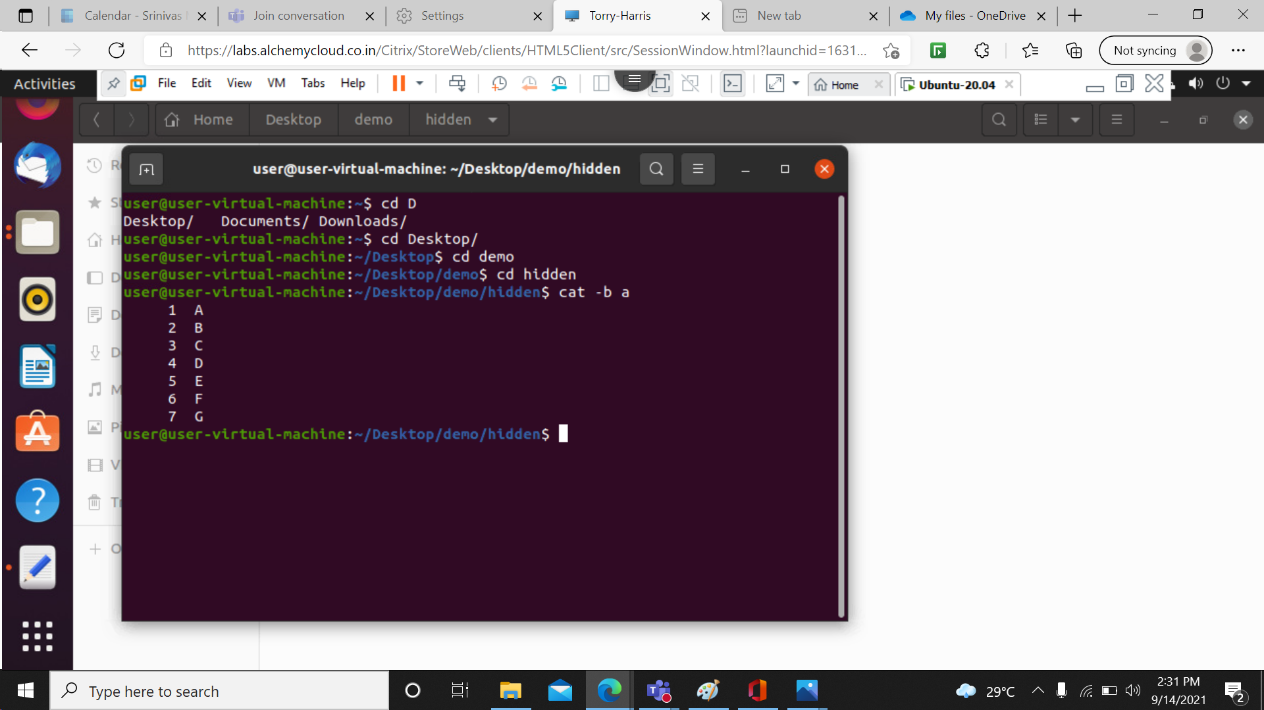

33>sort: SORT command sorts the contents of a text file, line by line.

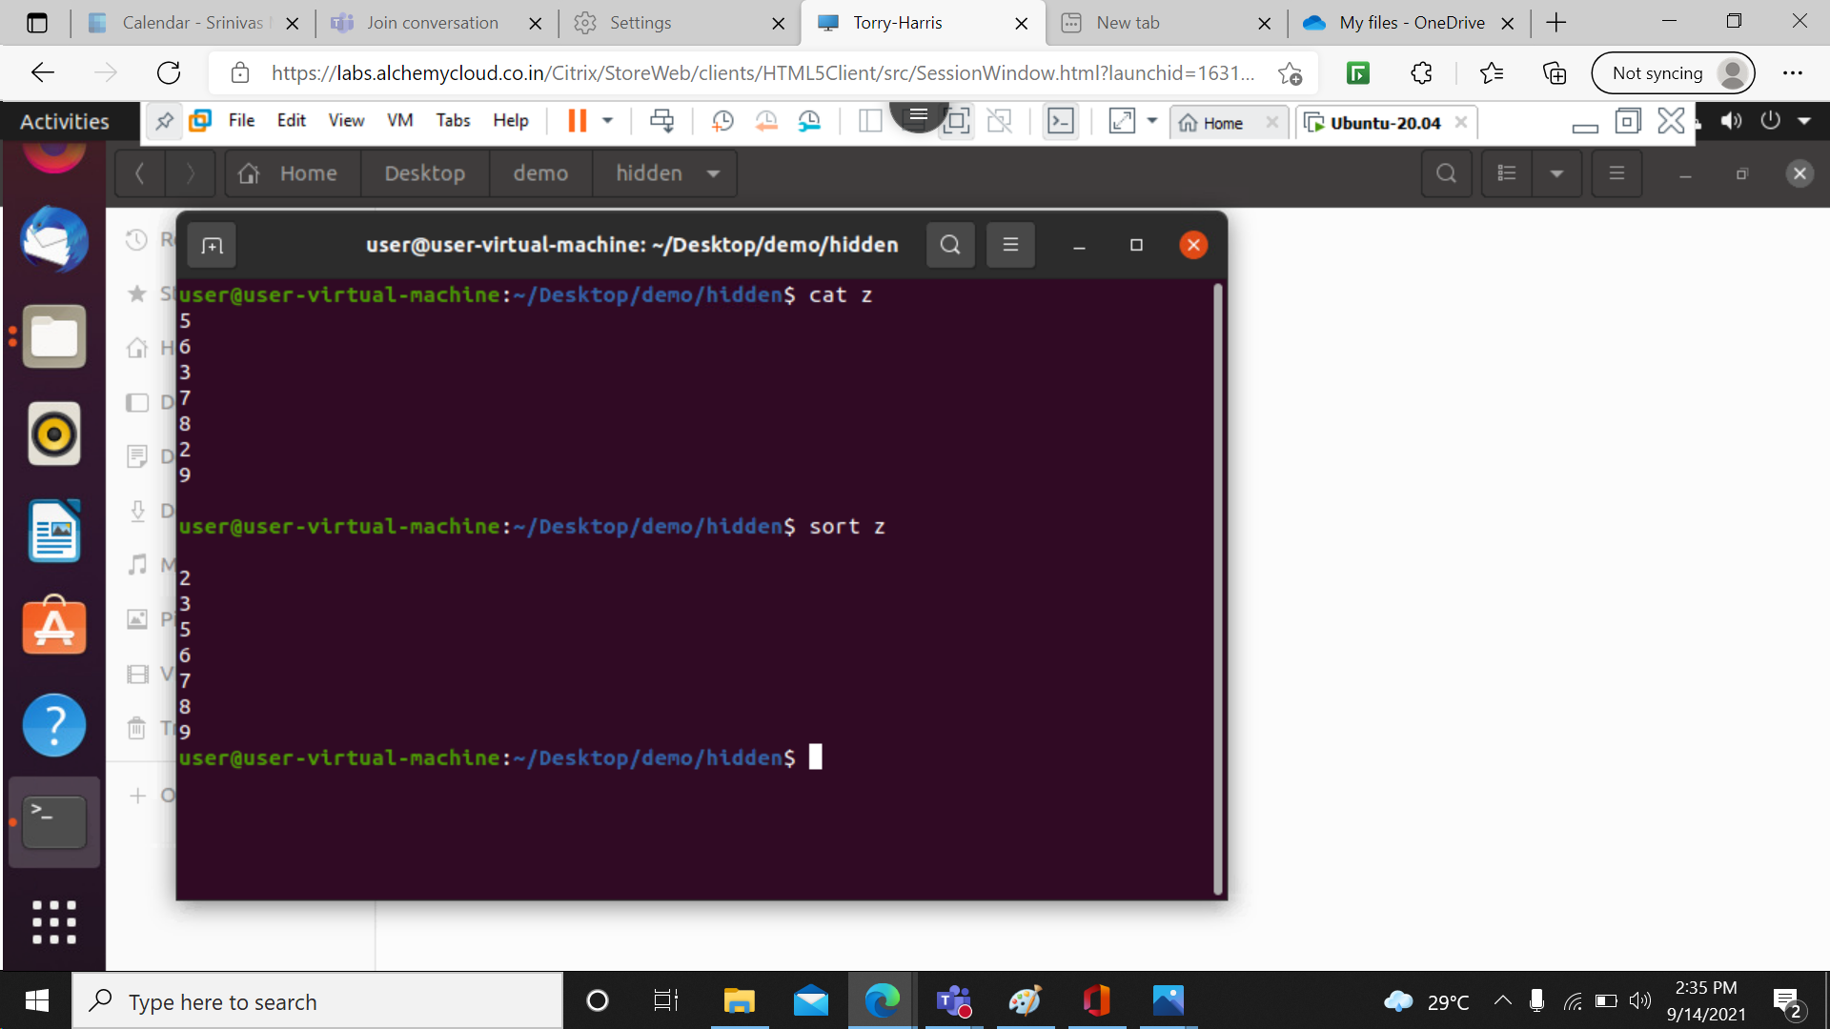

34> mkdir demo/2: It creates a new folder name 2 inside the folder demo.

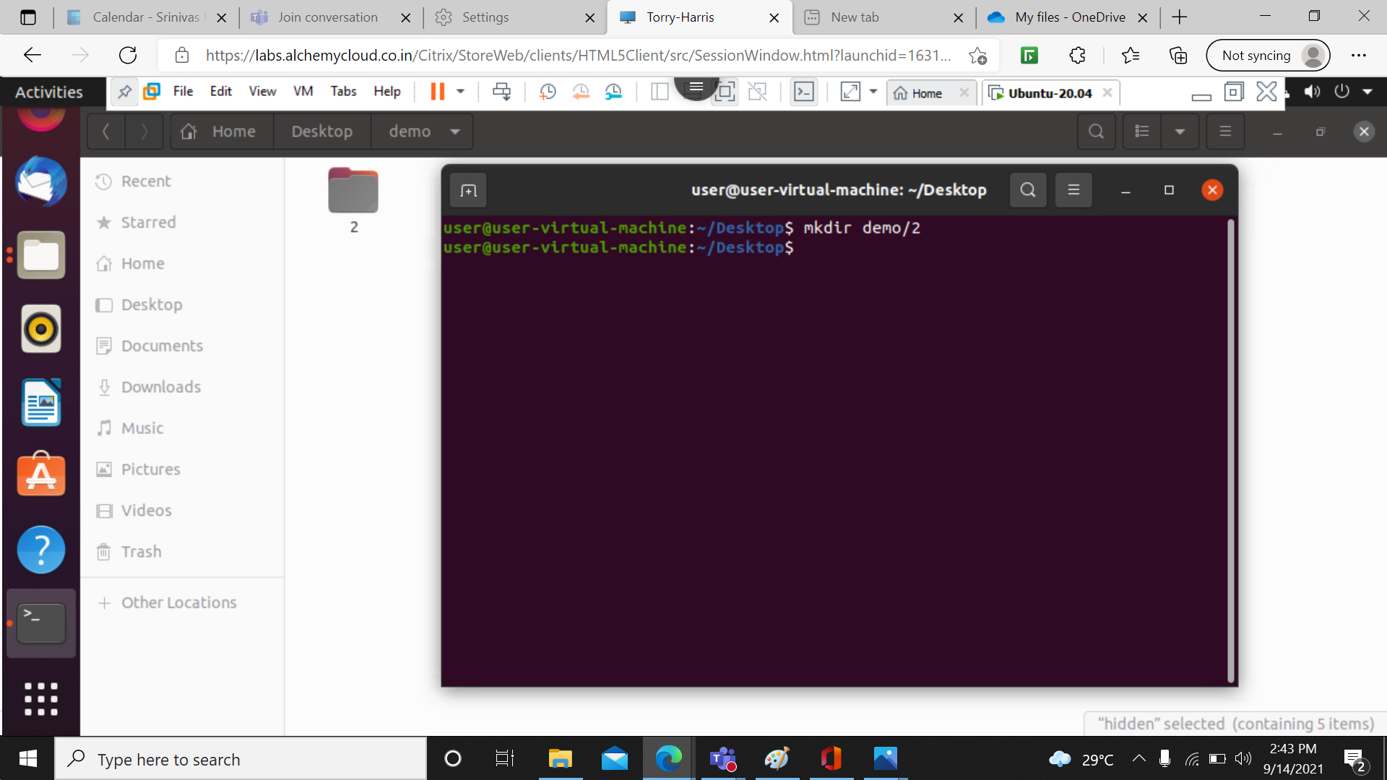

35> mkdir –p 1/2/3/4/5/6/7: p helps to create sub folders inside the parent directory.

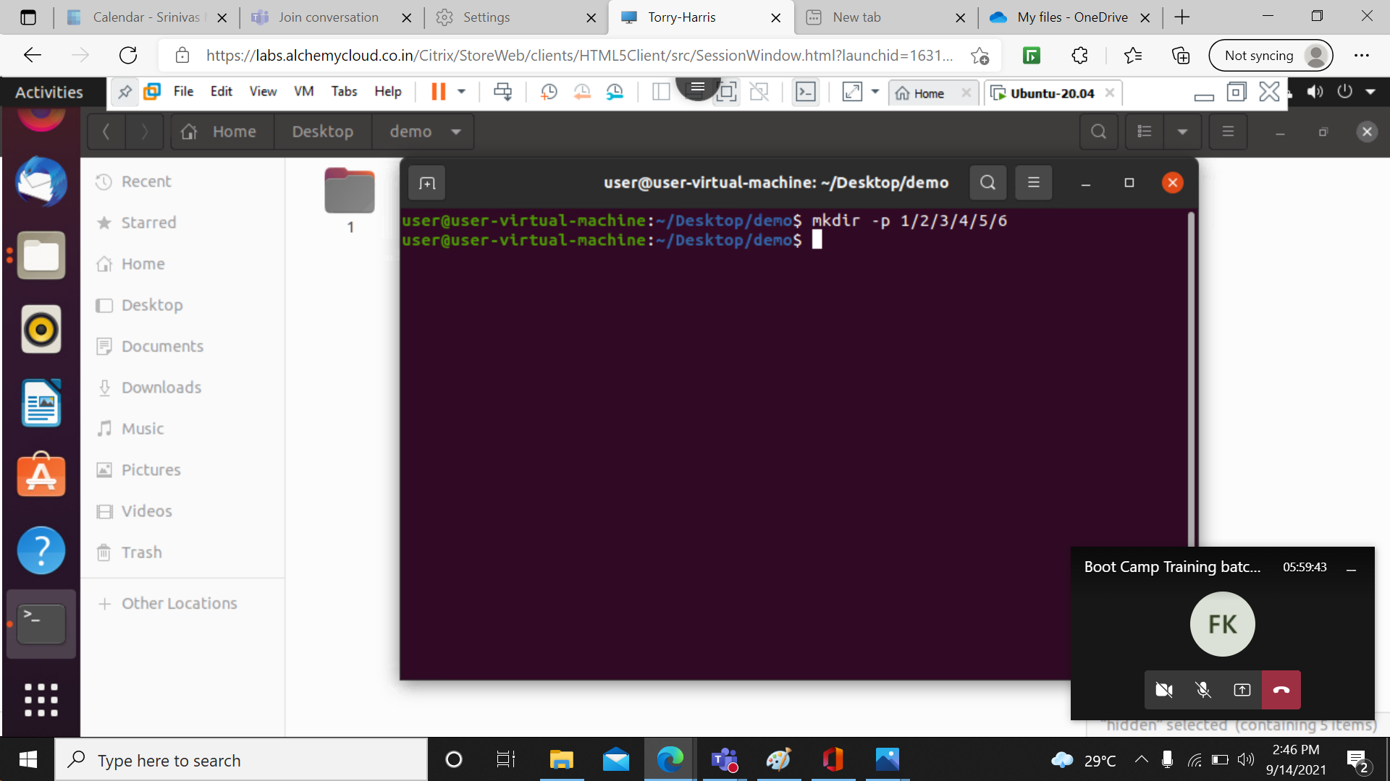

36> rm –rf 1: removes the entire folder and also its sub folders.

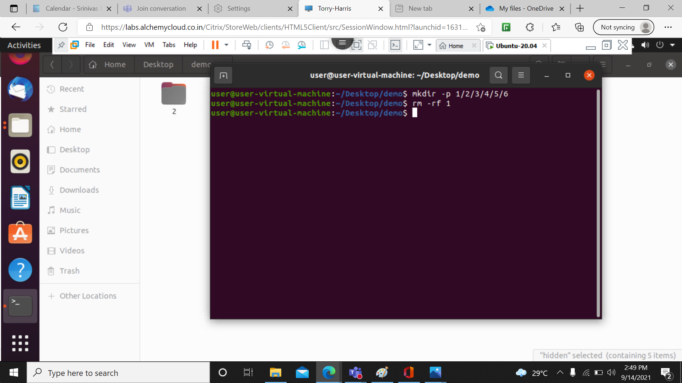

37> ls – lr: It will show the list in a long list format and reverse order.

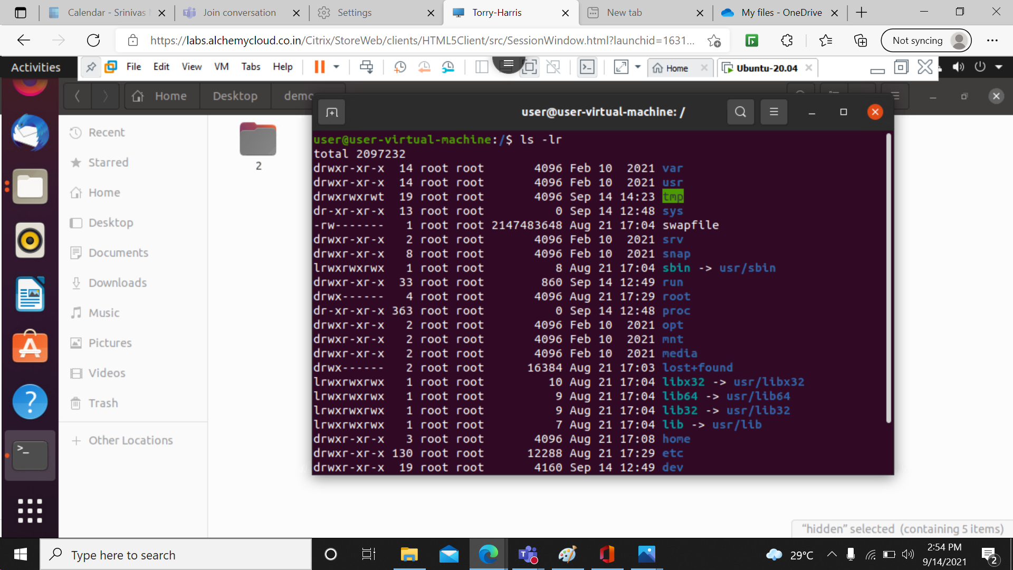

38> ls-a: It will show the list in a long list format and enlist the whole list of the current directory including the hidden files.

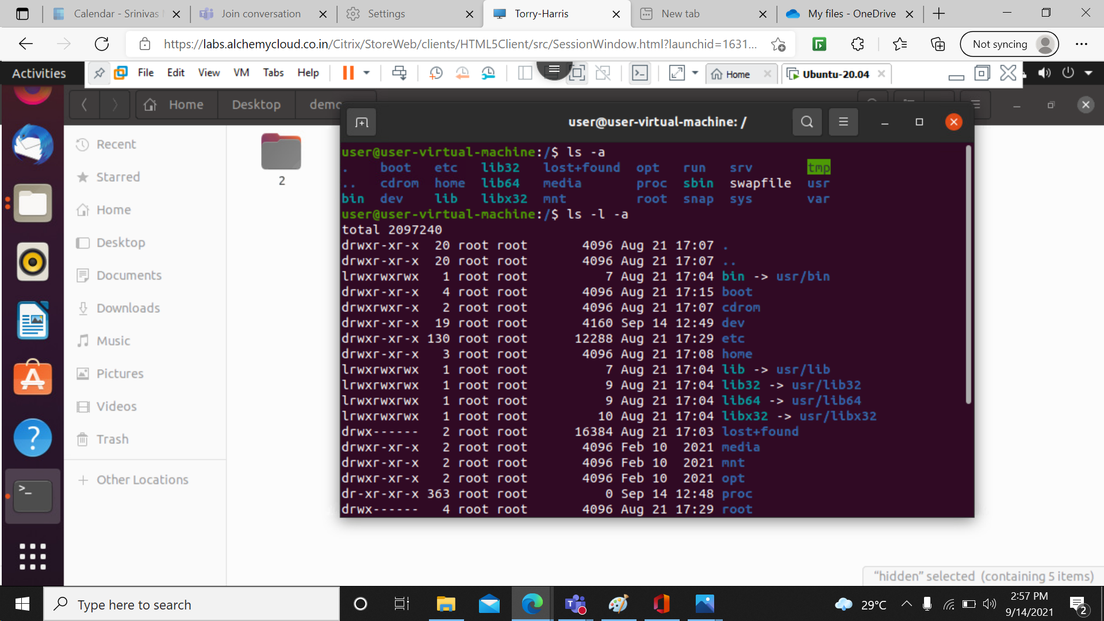

39> ls –lar: another method of above format and in reverse order.

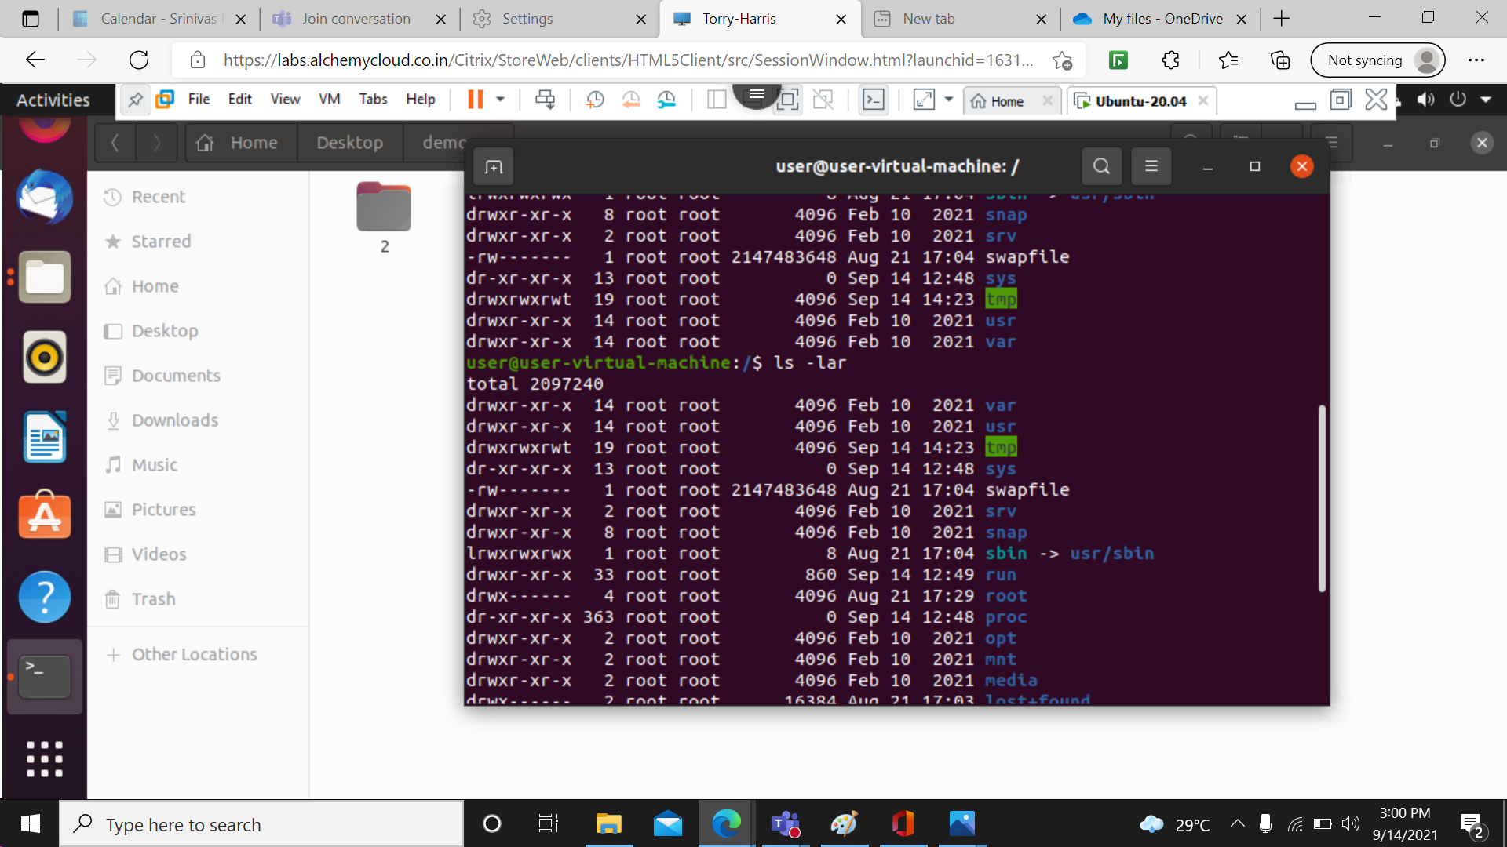

40> Passwd: passwd command in Linux is used to change the user account passwords. The root user reserves the privilege to change the password for any user on the system.

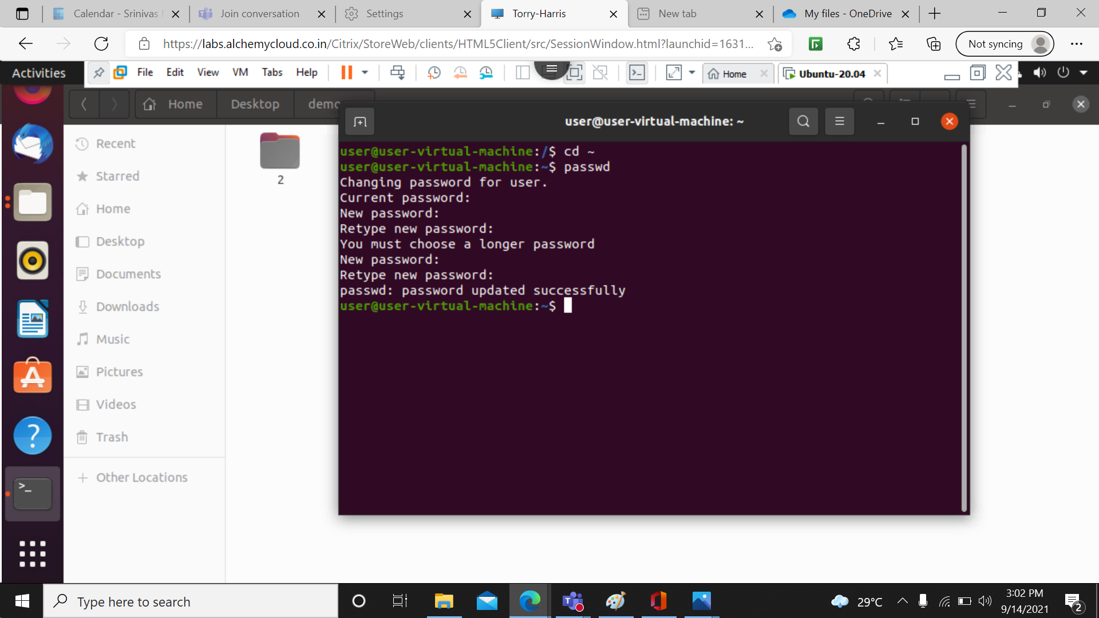

41> tree: Tree command is a recursive directory listing program that produces a depth indented listing of files. It is quite useful to find the directories that contains lot of sub-directories in Unix-like systems.

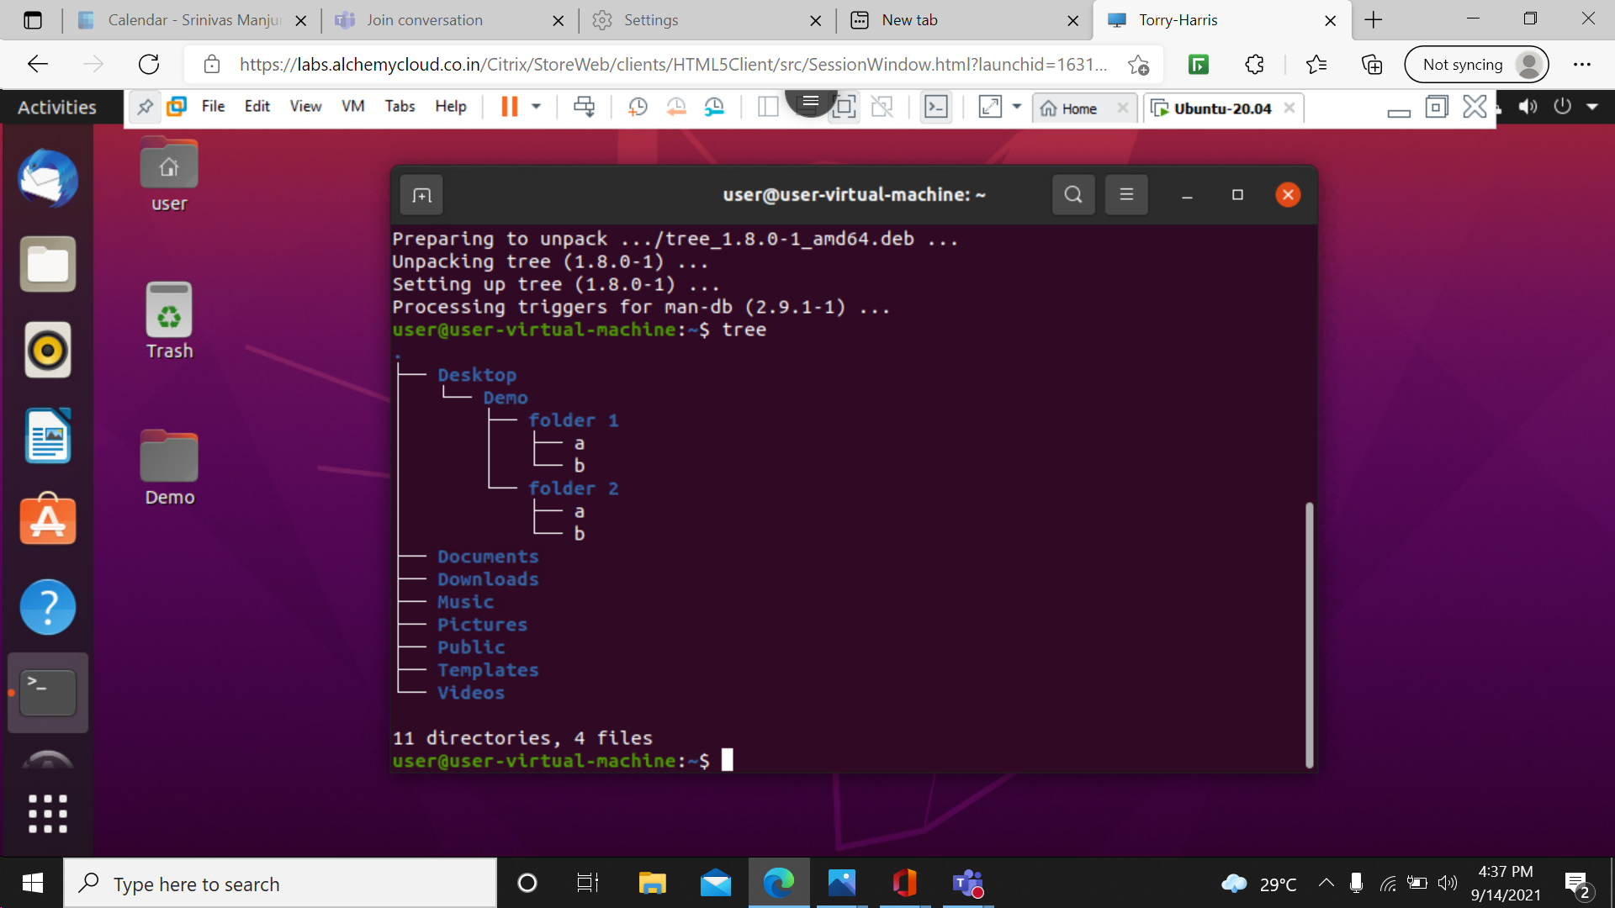

42> tree –help: it displays the help options and guide the user.

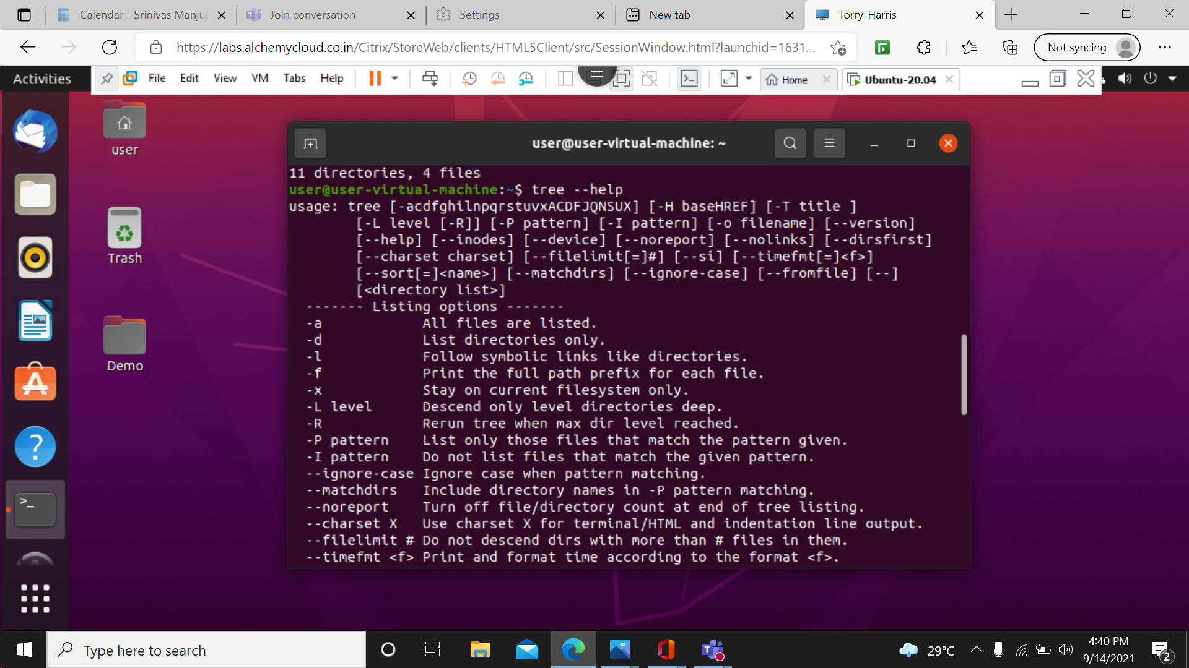

43> sudo apt –get update - sudo apt update is the command used to download and update the package information from all of the configured sources.

44> sudo apt-get upgrade- upgrade is used to install the newest versions of all packages currently installed on the system from the sources enumerated in /etc/apt/sources.list.

45> sudo apt-get update && upgrade- it will do both updating and upgrading process.